**Measuring and Significant Digits**

1. Measure the volume of liquid in the graduated cylinders below. Pay attention to units and precision.

a) _______________mL b) _______________mL

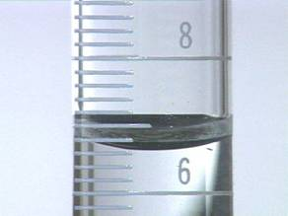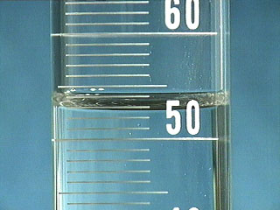

1. Measure the volume of liquid in the burettes below:

a) _______________mL

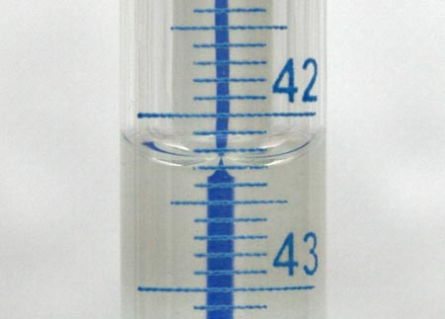

* 1. 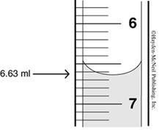_______________mL

1. Record the reading from the voltmeter shown below. ______________________________

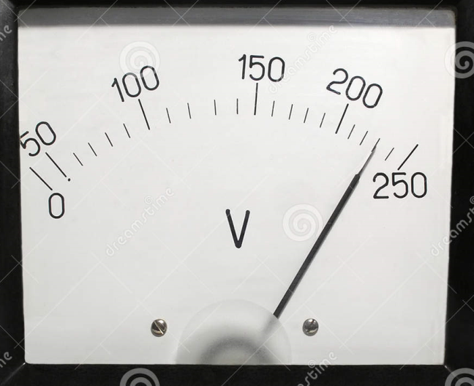

4) Using a ruler, measure the length of the following lines:

a) ________________________________________ length: _______ cm

b) _____________________________ length: _______ cm

c) _______________ length: _______ cm

d) ___ length: _______ cm

4. Indicate how many significant digits are contained in each of the following values.

|  |  |  |
| --- | --- | --- |
| a) 6.317 | e) 3.98 | i) 921 |
| b) 0.08091 | f) 207.0 | j) 0.00219 |
| c) 4.30 × 103 | g) 0.00010 | k) 92 100 |
| d) 12.0 | h) 4.0020 | l) 92 100. |

5. How many significant digits should be in the following answers? (Don’t work out the problems!)

|  |  |  |
| --- | --- | --- |
|  |  |  |
|  |  |  |
|  |  |  |