THIS IS A PRACTICE ASSESSMENT. Show formulas, substitutions, answers (in spaces provided) and units!
The following questions are about elementary particles.
1. State what is meant by an elementary particle, and what are the three types?
__________________________________________________________________________________

2. List the four forces, and their carriers. What are their relative strengths, and their ranges?
__________________________________________________________________________________

3. List which forces electrons are influenced by. 3. _____________________________________

4. List which forces quarks are influenced by. 4. _____________________________________

The following questions are about hadrons.
5. List the two types of hadron . 5. _____________________________________

6. What is the quark makeup of a baryon? Use the symbol “q” for quark and “q” for antiquark.
6. _________________

7. What is the quark makeup of a meson? Use the symbol “q” for quark and “q” for antiquark.
7. _________________

A particle has the quark combo of (uds).
8. What type of hadron is this particle? 8. _________________

9. What is its charge? 9. _________________

The following questions are about the standard model.
10. State the three-family structure of quarks in the standard model. Be sure to list the family number and the particles within that family.
__________________________________________________________________________________

11. State the three-family structure of leptons in the standard model. Be sure to list the family number and the particles within that family.
__________________________________________________________________________________

12. What is the Higgs particle (or Higgs boson)?
__________________________________________________________________________________

13. What is the significance of the Higgs boson in the context of the standard model?
__________________________________________________________________________________
The following questions are about conservation.
14. Is lepton number conserved in total, like baryon number, or is it conserved in another way? How is it conserved?
__________________________________________________________________________________

15. Use conservation principles to find out if the following reactions are possible:
(a) p + e⁻ → n + ν_{e} (e) e⁻ + e⁺ → γ + γ
(b) p + p → p + p + p + e⁺ + ν_{e} (f) e⁻ + e⁺ → n + γ
(c) p + p → p + p + π⁰ (g) p + p → n + ν
(d) p + p → π⁰ + π⁰ (e) e⁻ + μ⁺ → γ + γ

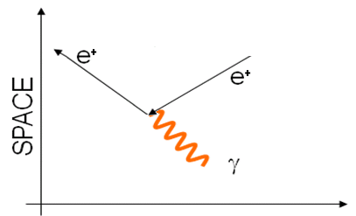
The following questions are about Feynman diagrams.
16. Explain what is happening in this Feynman diagram.

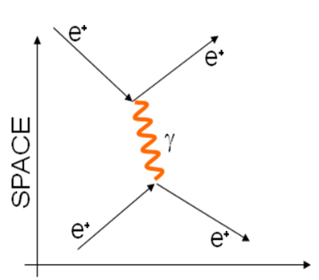
17. Explain why this Feynman diagram, showing a positron repelling a positron, is incorrectly drawn.

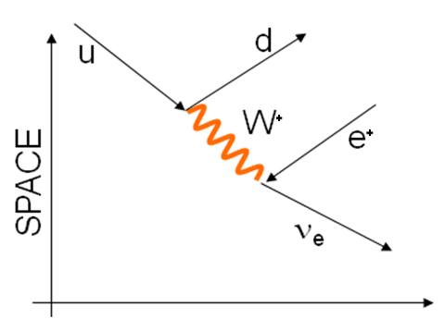
18. Explain what is happening in this Feynman diagram. What kind of decay is illustrated? Add two quarks to complete the top of the diagram so that it shows the common particles in the reaction.

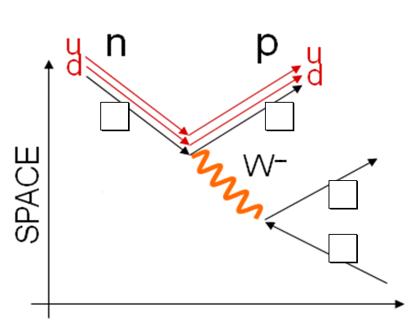
19. Fill in the boxes with the particles that are not identified in the Feynman diagram.

