**Unit 4 – The Wave Nature of Light**

**Topics covered:**

* What is Light?
* Young’s Double Slit Experiment
* Diffraction Gratings
* Wave Theory of Light
* Polarization
* Thin Film Interference

# What is Light?

Humans have been studying and experimenting with light for thousands of years, trying to figure out exactly what light actually is. Sir Isaac Newton, a famous, almost mythic, figure in western science during the 1600’s due to his groundbreaking work on gravity, forces and motion, had also studied and experimented with light and decided that it was made up of particles. However, there were a minority of scientists (namely Christiaan Huygens) who felt that light was in fact a wave. Both theories, however, were able to successfully explain several observed phenomena of light:

|  |  |  |
| --- | --- | --- |
| **Phenomenon** | **Particle Theory** | **Wave Theory** |
| Linear Propagation |  |  |
| Reflection |  |  |
| Refraction |  |  |
| Dispersion |  |  |
| Diffraction |  |  |

* A description of each phenomenon from each theory can be found in Appendix I.

# Young’s Double Slit Experiment

When two particles encounter each other, they collide (according to the laws of conservation of momentum and energy). When two waves encounter each other, they interfere (according to the principle or superposition). By observing what happens when two sources of light encounter each other, its true nature could be determined. If light is a particle, two connect bright spots that gradually fade to darkness should be observed. If light is a wave, an alternating pattern of bright and dark spots (a standing wave pattern) should be observed.

Particles through a Double Slit Waves through a Double Slit

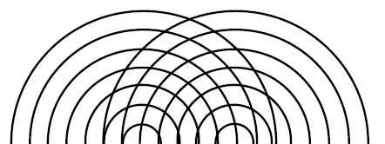

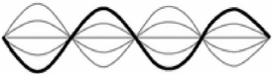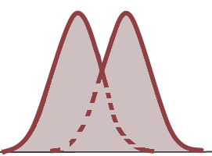

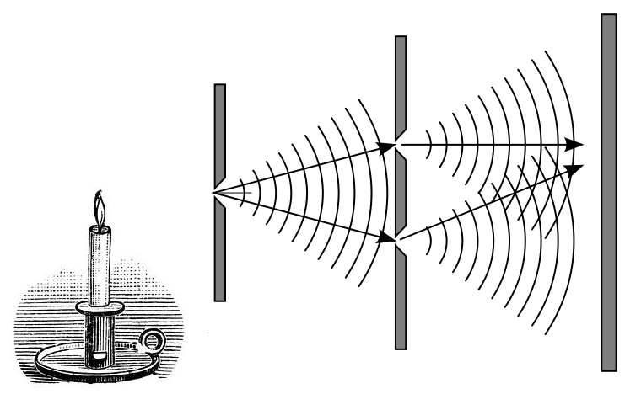Several double slit experiments were conducted which yielded two spots of light, seemingly confirming the particle nature of light. However, Thomas Young (1773-1829) understood that in order to observe a significant interference pattern, the two sources had to have the same wavelength, the same amplitude, and be in *phase* (see Appendix II). On top of this, the separation of the two slits had to be similar to the wavelength of the sources. Hypothesizing that the wavelength of light must be very small, he came up with an elegant solution to test the wave nature of light:

A single source was used, its light travelling first through a single slit and then upon d double slit. For the double slit Young burned a piece of glass to blacken it and then etching two slits onto it using two razor blades, thus making the source separation extremely small. Using a single source and dividing it onto two ensured both sources were identical. With this exceedingly clever setup, Young was able to indeed observe an interference pattern and assert light’s wave properties:



The analysis of the interference pattern is identical to that of water waves, and by using the already known 2-D interference equations (see Appendix III), Young was able to first determine the wavelength of light.

**2-D Interference Equations**

|  |  |
| --- | --- |
| Equations |  |
|  | = Path length from source 1 to node on nodal line *n $P_{n}S_{2}$*  = Path length from source 2 to node on nodal line *n*  = path length difference  *n* = nth nodal line (*n = 1,2,3,…*)  *λ* = wavelength of sources |
| $\sin\left(θ_{n}\right)=\left(n-\frac{1}{2}\right)\frac{λ}{d}$ | $θ_{n}$ = angle to node on nth nodal line  *n* = nth nodal line (*n = 1,2,3,…*)  *λ* = wavelength of sources  *d* = source separation |
| $λ=\frac{x_{n}d}{L\left(n-\frac{1}{2}\right) }$ | $x_{n}$ = shortest distance from perpendicular bisector to  node on nth nodal line  *n* = nth nodal line (*n = 1,2,3,…*)  *λ* = wavelength of sources  *d* = source separation  *L* = shortest distance from sources to screen |
| $Δx=\frac{Lλ}{d }$ | $Δx$ = separation between adjacent nodes on screen  *λ* = wavelength of sources  *d* = source separation  *L* = shortest distance from sources to screen |

2-D Interference Pattern:

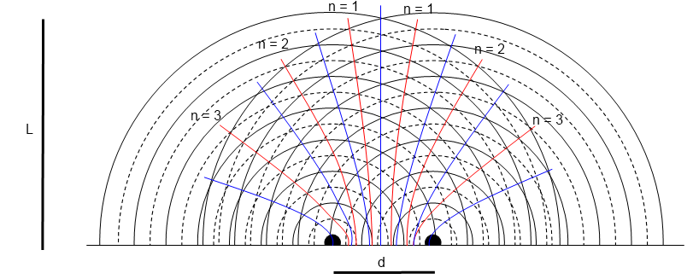

*image courtesy of *Nelson Physics12*

# Diffraction Gratings

Instead of using just two slits, multiple slits can also be used to create an interference pattern. The more slits (gratings) there are, the sharper the interference pattern becomes. A barrier with multiple slits is called a *diffraction grating*.

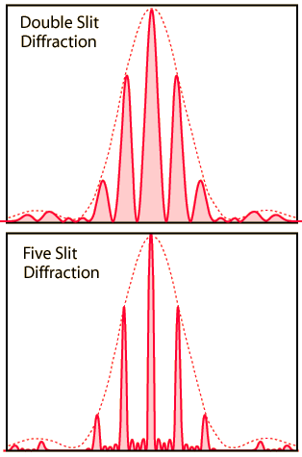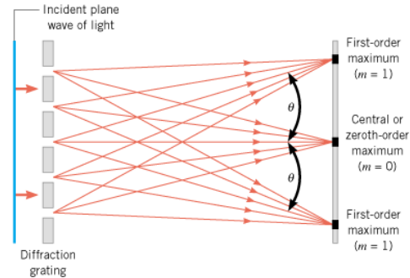

*image courtesy of Physics, 7th Edition. John D. Cutnell, Kenneth W. Johnson 2007*

The analysis of the interference pattern produced by a diffraction pattern follows directly from that of the double slit, but the maxima (bright spots) are more defined than the nodes (dark spots). Therefore the equations consider maxima (*m*) instead of nodes (*n*):

*image courtesy of HyperPhysics, Georgia State University*

**Diffraction Gratings equations**

|  |  |
| --- | --- |
| Equations |  |
|  | = Path length from source 1 to bright spot on maxima line *m $P_{m}S_{2}$*  = Path length from source 2 to bright spot on maxima line *m*  = path length difference  *m* = mth maxima line (*m = 0,1,2,3,…*)  *λ* = wavelength of sources |
| $d=\frac{w}{N}$ | *w* = total width of grating  *N* = number of gratings (slits)  *d* = source separation |
| $\sin\left(θ_{m}\right)=\frac{mλ}{d}$ | $θ_{m}$ = angle to bright spot on mth maxima line  *m* = mth maxima line (*m = 0,1,2,3,…*)  *λ* = wavelength of sources  *d* = source separation |
| $λ=\frac{x_{m}d}{mL }$ $(m>0)$ | $x_{m}$ = shortest distance from perpendicular bisector to bright spot on mth maxima line (*m>0*)  *m* = mth maxima line  *λ* = wavelength of sources  *d* = source separation  *L* = shortest distance from sources to screen |
| $Δx=\frac{Lλ}{d }$ | $Δx$ = separation between adjacent bright spots on screen  *λ* = wavelength of sources  *d* = source separation  *L* = shortest distance from sources to screen |

**Single Slit Diffraction**

An interference of light can also be observed when passing through a single slit whose width approximates the wavelength of light used. Further information can be found in Appendix IV.

# Wave Theory of Light

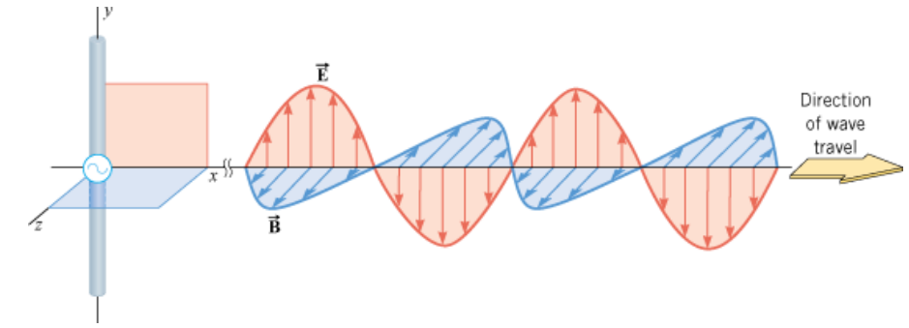

*image courtesy of *Physics, 7th Edition*. John D. Cutnell, Kenneth W. Johnson 2007

* Light consists of changing electric field and magnetic field, and is hence called *electromagnetic* (EM) radiation
* The electric field and magnetic field are perpendicular to each other and in phase
* Both the electric and magnetic fields are perpendicular to the direction of propagation (i.e. EM radiation waves are transverse)

From this perspective of considering light as a series of electric and magnetic field waves, we can understand and predict other phenomena associated with light…

# Polarization

Most light sources emit light with their electric and magnetic fields oscillating in random directions (but perpendicular to their direction of travel, of course). This type of light is called *unpolarized* light. Once it encounters a polarized filter/lens, half of its initial intensity has been absorbed, as it permits light oscillating in one direction is allowed to pass (transmit), and in the perpendicular direction is blocked (absorbed).

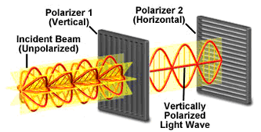

If polarized light encounters another polarizing filter, the amount of light that is transmitted depends on the angle between the polarized light and the blocking axis of the filter. Of this angle equals 0°, all of the incident light is transmitted. If the angle is 90°, none of the light is transmitted.

The transmission of unpolarized and polarized light when encountering a polarized filter is summarized in Malus’ law:

**Malus’s law:**

$$I_{1}$$

$$I_{0}$$

$$I_{2}$$

$$I_{1}$$

$$I_{0}$$

$$I_{2}$$

$I_{1}={\frac{1}{2}I}_{0}$

$I_{2}=I_{1}\cos^{2}{θ}$

**4 Ways of Polarizing Light**

1. Polarizing Filters (as discussed above)
2. Double Refraction by Anisotropic Crystals (e.g. calcite, mica, sugar, quartz, etc):

* 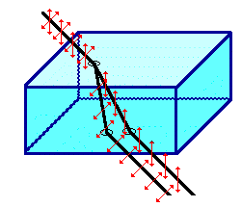A component of oscillating light in one direction travels at a different speed through the substance than light travelling in the other (perpendicular) direction, and hence refract at different angles, which separates them upon exiting the substance.

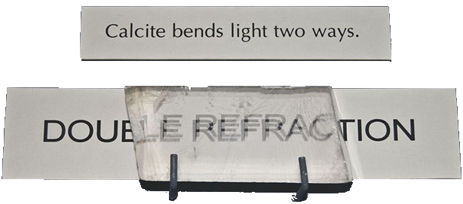

1. Reflection

* Light reflected by a non-metallic surface is partially polarized in the horizontal plane.
* 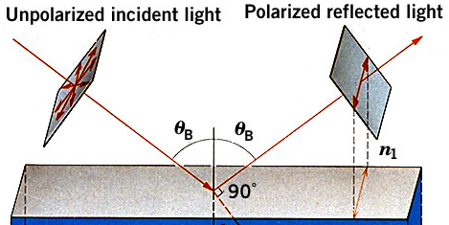More light in the vertical plane is absorbed than the horizontal.
* Polarized sunglasses are designed to block the reflected horizontally polarized light (glare!)



1. 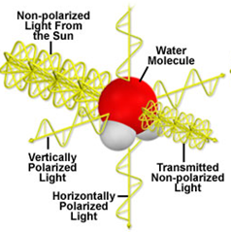Scattering

* When unpolarized light from the Sun encounters water and other particles that make up our atmosphere on earth, the particles absorb the light, jiggle, and then re-emit it in all directions (scattering).
* This re-emitting process is not uniform, as even though light re-emitted parallel to its original direction is still unpolarized, re-emitted light scattered perpendicular to the original direction is polarized.
* This effect can be noted while viewing the daytime sky by a rotating polarized filter: the sky will dim and brighten as it rotates.

# Thin Film Interference

Recall: Partial Transmission & Reflection of waves: Partial Transmission & Reflection of light:

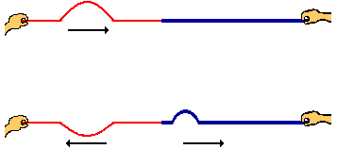

$$θ_{r}$$

$$θ_{i}$$

incident ray

reflected ray

$$θ_{R}$$

refracted ray

n1

n2

***fast medium slow medium***

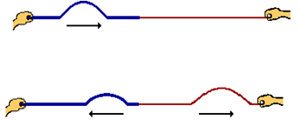

***slow medium fast medium***

When considering light as a wave, it obeys the same rules when it encounters a new medium () as waves do. Transmitted (refracted) rays slightly change their wavelength (colour) such that when light slows down its wavelength increases, and when it speeds up it decreases. Reflected ray can undergo a crest inversion, which causes a phase shift by a factor of $\frac{λ}{2}$ if the light slows down in the new medium.

|  |  |  |  |  |
| --- | --- | --- | --- | --- |
|  | **Refracted Ray** |  | **Reflected Ray** | |
| Wavelength |  | Crest Inversion | Phase Shift |
| **n1 < n2**  (fast to slow) | LONGER |  | YES |  |
| **n1 > n2**  (slow to fast) | SHORTER |  | NO | 0 |

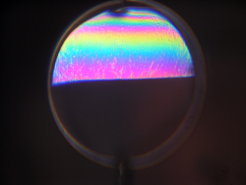**Thin Films**

When the thickness of a film is comparable to the wavelength of light, an interference pattern is produced, such as on the surface of a soap bubble or a thin layer of gasoline on the surface of a puddle.

Light reflected from the top layer of the film interferes with light that reflects off of the bottom layer of the film. If the difference between the phase shifts of these two sources of light is a whole number ratio of their wavelength, constructive interference will occur (bright spot). If the difference is a whole number ratio +/- $\frac{λ}{2}$, destructive interference will occur (dark spot).

|  |  |
| --- | --- |
| **Differences in Phase Shifts** | **Interference** |
| $$nλ , n=0,1,2,3,…$$ | constructive (bright spot) |
| $$\left(n+\frac{1}{2}\right)λ , n=0,1,2,3,…$$ | destructive (dark spot) |

Phase shift can occur as a result of reflection or due to the extra path length travelled by the ray that reflects off of the bottom layer.

air

$\frac{λ}{2}$ shifted

$\frac{λ}{2}$,

$λ$ shifted

air

soap

DARK SPOT

e.g. soap film on glass

* Red ray is shifted by $\frac{λ}{2}$ from reflection
* Blue ray is shifted by $\frac{λ}{2}$ from moving

from top layer to bottom layer

* Blue ray is shifted by another $\frac{λ}{2}$ from

moving from bottom layer back to the

bottom layer

**Wavelength Changes in Thin Films**

The frequency of light (as with all waves) depends solely on its source, and this frequency never changes, even when encountering a new medium. Since it is light’s frequency that we perceive as colour, the colour of light also never changes. Its speed, however, will change depending on the medium through which it travels, as does its wavelength (according the universal wave equation).

We can determine the change in wavelength when light exits one medium (*1*) and enters another (*2*) as long as we know the indices of refraction (*n*) for the two substances:

$n_{1}=\frac{c}{v_{1}}$ $n_{2}=\frac{c}{v_{2}}$ where *c* = speed of light in vacuum (2.998x108 m/s)

*vs* = speed of light in substance *s*

$n_{1}=\frac{c}{fλ_{1}}$ $n_{2}=\frac{c}{fλ_{2}}$ where *v = fλ* (universal eave equation)

*f* is the same in both media

$$n_{1}λ_{1}=\frac{c}{f}=n_{2}λ_{2}$$

$$\frac{n_{1}}{n_{2}}=\frac{λ_{2}}{λ_{1}}$$

This result is very useful when making anti-reflective coatings for shiny objects (e.g. eye glasses, building windows) as it the thicknesses of the coating can be determined to ensure destructive interference.

**Air Wedges**

An interference pattern can also be created when a very thin layer of air is illuminated. This pattern can be used to measure thickness of very small objects, such as a single strand of hair:

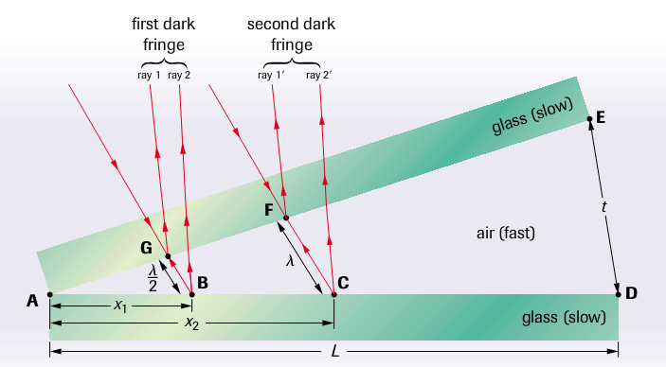

*image courtesy of *Nelson Physics12*

As the thickness of the wedge increases, alternating bands of light and dark spots are created. Looking at the first two bands, we can see that *ΔAGB* and *ΔADE* are similar, such that

$$\frac{x_{1}}{L}=\frac{(\frac{λ}{2})}{t}$$

$$x_{1}=\frac{Lλ}{2t}$$

Similarly, *ΔAGB* and *ΔADE* are also similar:

$$\frac{x_{2}}{L}=\frac{λ}{t}$$

$$x_{2}=\frac{Lλ}{t}$$

Combining the two results, we can determine *Δx*, the distance between dark spots:

$$Δx=x_{2}-x_{1}$$

$$Δx=\frac{Lλ}{t}-\frac{Lλ}{2t}$$

$$Δx=\frac{Lλ}{2t}$$

This result allows us to solve for *t*, the thickness of the wedge, which can be the thickness of a piece of paper or a hair, or whatever object is propping up the wedge. These thicknesses can then be determined by measuring the length of the air wedge and the distance between dark spots (assuming the wavelength of light used is known).

# Appendix I – Light Phenomena from Particle and Wave Perspectives

**Phenomena #1 – Linear Propagation**

According to Newton’s 1st law, the law of inertia, any object (particle) in moving uniformly will maintain its state of uniform motion unless a net external force is acted upon it. As long as no external forces act on light, it will travel in straight lines.

Although individual waves spread out in all directions, plane waves can be created by several waves travelling together (termed *wavelets*), such that their *wavefront* travels in a straight line.

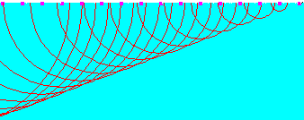

**Phenomena #2 - Reflection**

When light encounters a smooth (i.e. shiny) surface, it reflects. This interaction obeys the law of reflection such that the angle of incidence, $θ_{i}$, is equal to the angle of reflection, $θ_{r}$ ($θ_{i}=θ_{r}$) and the incident ray, reflected ray, and the normal all lie in the same plane:

reflected ray

incident ray

$$θ_{r}$$

$$θ_{i}$$

Particles as well as large objects are found to obey the law of reflection (e.g. pool balls striking the bumper, basketball bounce-passes, etc.).

Waves also obey the law of reflection as witnessed with water waves reflecting of barriers as well as sound waves off of solid objects like walls.

**Phenomena #3 - Refraction**

When light exits one medium and enters another, the direction of its motion changes – sometimes moving towards the normal line, sometimes away, depending on the two media involved.

Water waves are known to refract when the depth of water changes, as do sound waves when the density of air changes. When waves slow down they bend towards the normal, when they speed up they bend away from the normal.

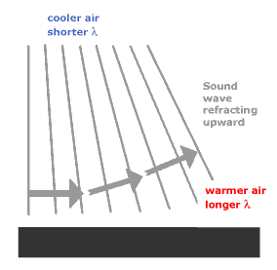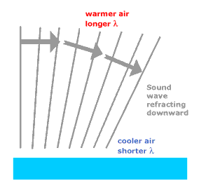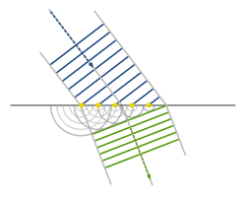

water waves refracting at a boundary sound waves refracting in air at different temperatures

When particles encounter a boundary at an angle, they

will bend toward the normal if moving faster, and away from

the normal when moving slower.

**Phenomena #4 - Dispersion**

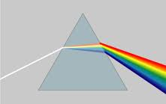One (of several) remarkable discoveries made by Newton was that coloured light was not a distortion of white light, but white light was made up of coloured light. He studied the phenomenon of dispersion, which is the breaking of white light into its constituent colours (like through a prism). This phenomena, as it is based on refraction, could be accurately described by both models:

Particles: each colour particle would have a different mass: heavier particles (red, yellow) speed up less, so bend less, than lighter particles (purple, blue).

Waves: Each colour has its own speed in a medium (in this case, glass). Red and yellow waves move faster than purple and blue waves.

**Phenomena #5 – Diffraction**

In 1664, Francisco Grimaldi observed that light appeared in areas, as shown below:

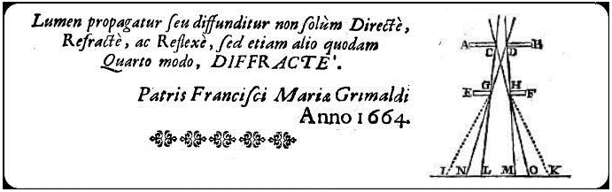

The range in which light was expected to be found was between ***N*** and ***O***. However, light was also observed by Grimaldi to be found between ***I*** and ***K***, a phenomenon he called *Diffraction.*

Diffraction was very difficult for Newton to explain using particles. He said that collisions between light particles themselves could have caused the effect, when he wasn’t doubting the results altogether.

Diffraction of waves, however, is clearly demonstrated and understood. How much a wave bends depends on both the wavelength of the wave and the size of the opening of the barrier:

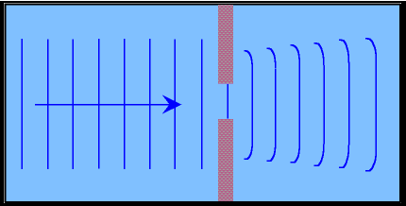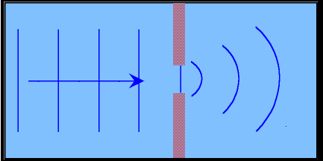 For the same opening, long-wavelength waves diffract more than short-wavelength waves:

For waves with the same wavelength, smaller openings result in more diffraction than larger openings:

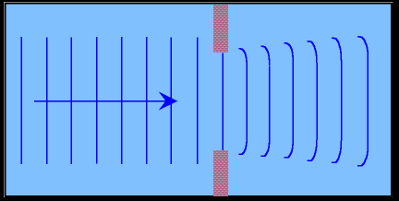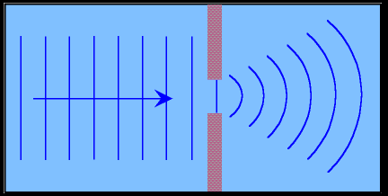

Sound waves also diffract – this is why we can hear things around corners

# Appendix II – Phase Shifts

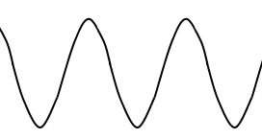

Black wave – original wave

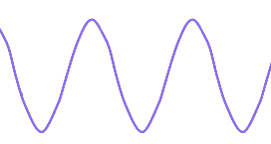Purple wave – is horizontally shifted by a

$\frac{λ}{2}$

distance $\frac{λ}{2}$ compared to the black wave.

Destructive interference occurs.

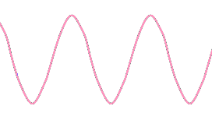Pink wave – is horizontally shifted by a

distance $λ$ compared to the black wave.

$$λ$$

Constructive interference occurs.

Completely Out of Phase $\left(\frac{λ}{2}\right)$:

Whenever two waves that differ in phase by a factor of $±\left(n+\frac{1}{2} \right)λ$ interfere with each other (*n = 0,1,2,3*…), complete destructive interference occurs (i.e. node).

In Phase ($λ$):

Whenever two waves that differ in phase by a factor of $±nλ$ interfere with each other (*n = 0,1,2,3*…), complete constructive interference occurs (i.e. supercrest/trough).

Out of Phase:

Whenever two waves that differ in phase by a factor that is not a multiple of $\frac{λ}{2}$, interference occurs according to the principle of superposition of waves (no *complete* interference occurs).

# Appendix III – 2-D Wave Interference Equations - Derivations

Two sources, in phase, with the same wavelength and amplitude will create the 2D interference pattern shown to the right:

Where a crest from one source meets a trough from another, a node is formed. In the 2D interference pattern, *nodal lines* form as a result of destructive interference between the two sources. These nodal line, where the amplitude of the medium is zero, are shown below:

**n = 1**

**n = 1**

**n = 2**

**n = 2**

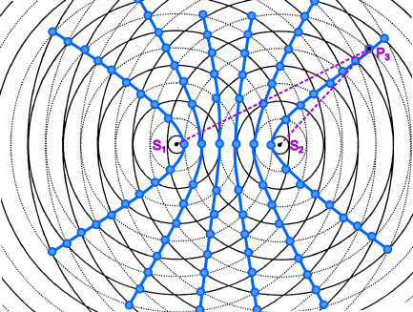

**n = 3**

**n = 3**

**Path Length Difference**

The path length difference from each source to a single node, chosen from each nodal line, can be determined as follows:

For n = 3:

$\left|P_{3}S_{1}-P_{3}S_{2}\right|=\left|6\frac{1}{4}λ-3\frac{3}{4}λ\right|=\frac{5}{2}λ$

For n = 2:

$\left|P_{2}S_{1}-P_{2}S_{2}\right|=\frac{3}{2}λ$

For n = 1:

$\left|P_{1}S_{1}-P_{1}S_{2}\right|=\frac{1}{2}λ$

In general, the path length difference from each source to *any* node on the nth nodal line is given by the following:

$\left|P_{n}S_{1}-P_{n}S_{2}\right|=\left(n-\frac{1}{2}\right)λ$

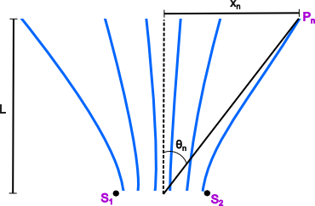 **Nodal Pattern**

Considering only the nodal pattern:

$$\tan{θ}=\frac{x_{n}}{L}$$

For really small angles, $\tan{θ}≅ \sin{θ}$

For small angles to occur, $x_{n}≪L$, which means the distance to the screen where the nodes are observed ($L$) must be very large.

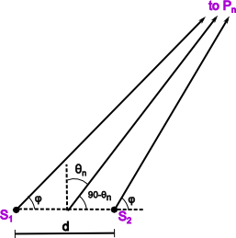

$\sin{θ}=\frac{x_{n}}{L}$

Zooming in to the two sources, a number of angles can be defined, as shown to the right.

***d*** = source separation

However, since ***L*** is very large, ***Pn*** is very far away, and the three solid lines in the diagram approach parallel.

From the next diagram we get the following relationship:

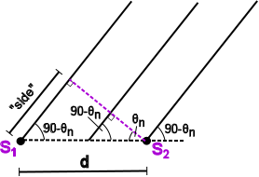

$$\sin{θ}=\frac{"side"}{d}$$

But “side” is simply the path length difference from each source to the node, so

$$\sin{θ}=\left(n-\frac{1}{2}\right)\frac{λ}{d}$$

Combining the two above equations, we also get:

$\sin{θ}=\frac{x_{n}}{L}=\left(n-\frac{1}{2}\right)\frac{λ}{d}$

$λ=\frac{x_{n}d}{L\left(n-\frac{1}{2}\right)}$

**Nodal Spacing**

The following demonstrates the distance between any adjacent nodal lines (* recall: $x_{n}≪L$)

$∆x=x_{n}-x_{\left(n-1\right)}$

$∆x=\left(n-\frac{1}{2}\right)\frac{Lλ}{d}-\left(\left(n-1\right)-\frac{1}{2}\right)\frac{Lλ}{d}$

$∆x=\frac{\left(n-\frac{1}{2}\right)Lλ}{d}-\frac{\left(n-\frac{3}{2}\right)Lλ}{d}$

$∆x=\frac{nLλ - \frac{nLλ}{2}- nλL + \frac{3nLλ}{2}}{d}$ $∆x=\frac{Lλ}{d}$ nodal spacing is constant

$∆x=\frac{Lλ}{d}$

# Appendix IV - Single Slit Diffraction

When light (or any other wave) passes through a single slit, it too can produce an interference pattern, but one with a doubly-thick centre maximum and quickly diminishing secondary bright spots. Recall, however, that for noticeable diffraction, and therefore noticeable interference to occur, the wavelength must be close to the size of the opening.

Single Slit pattern:



Double Slit pattern:



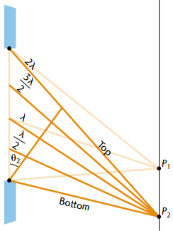

To understand this phenomenon, light passing through a single slit

must be considered as originating from numerous individual sources

(i.e. Huygen’s wavelets) along the plane of the slit. These sources

interfere with each other at angles as their path lengths differ.

The following equations, similar to those of a double slit and diffraction

grating, describe the single slit interference pattern (note: the central

maximum is double the width of a single maximum, or, *2Δy* :

**Single Slit Equations**

|  |  |  |
| --- | --- | --- |
| **Nodes (Dark Spots)** | **Maxima (Bright Spots)** |  |
| $$\sin\left(θ_{n}\right)=\frac{nλ}{w}$$ | $$\sin\left(θ_{m}\right)=\left(m+\frac{1}{2}\right)\frac{λ}{w}$$ | *n* = nth nodal line (*n = 1,2,3,…*)  m = mth maxima line (*m = 1,2,3,…*)  *λ* = wavelength of sources  *w* = width of single slit |
| $λ=\frac{x_{n}w}{mL }$ | $λ=\frac{x_{m}w}{L\left(m+\frac{1}{2}\right) }$ | $x_{n}$ = shortest distance from perpendicular bisector to  node on nth nodal line $x_{m}$ = shortest distance from perpendicular bisector to  maxima on mth maxima line  *L* = shortest distance from sources to screen |
| $Δy=\frac{Lλ}{w }$ | $Δy=\frac{Lλ}{w }$ | $Δy$ = separation between adjacent nodes or maxima on screen |