Unit III – Energy & Society – Nuclear Physics

Topics covered:
- The Nucleus
- Radioactive Decay
- Radioactive Half-Life
- Nuclear Fission, Energy of Fission
- Nuclear Fusion
- Fusion, Stars and the Elements

The Nucleus

Inside any nucleus is found protons and neutrons, the numbers of which can be determined form the periodic table of elements as follows:
e.g. carbon
⁶C¹²
Carbon

atomic numbe (Z) atomic mass (nucleon number) (A)

- number of protons = Z

- number of neutrons = A-Z

- The number of protons identifies the element

Isotopes

Isotope - Atoms of the same element that contain different number of neutrons
e.g. isotopes of hydrogen:
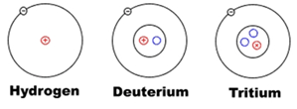

Atomic masses listed on the periodic table are all listed as decimals. But if this is supposed to be the count of the masses of protons and neutrons in the nucleus, how could it ever be a decimal?

Well, the atomic mass of an element is actually the average masses of all its different isotopes. Most carbon that exists is Carbon-12, and so Carbon’s atomic mass reflects this: Z_{carbon} = 12.01

Nuclear Strong Force vs Electromagnetic Force

Stable nuclei are stable because the repulsion force form the protons (EM force) is balanced by the attractive nuclear strong force from the protons and neutrons.
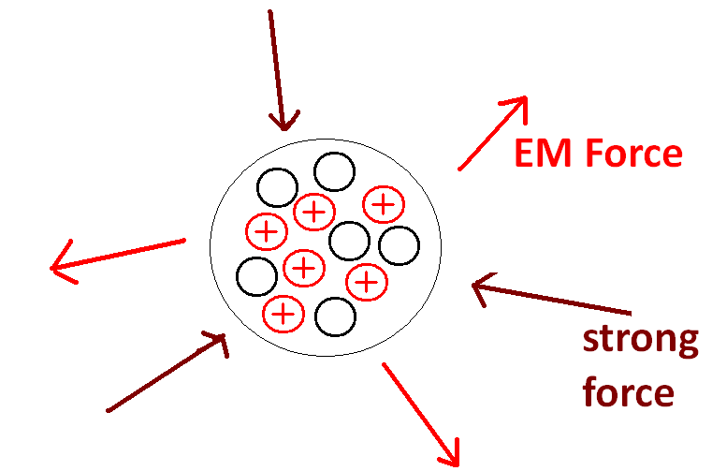
e.g. Carbon
Each proton is repelled by every other
p⁺ = 6 proton in the nucleus (r_{electromagnetic force} = ∞)
N = 6 Each proton is attracted only by those protons and neutrons close to it
(r_{nuclear strong force} = 10⁻¹⁵ m)

Nuclear Stability

As nuclei get bigger and bigger, more and more neutrons are needed to maintain stability (more p⁺ means more EM force, so more N means more nuclear strong force). On the graph below, each data point represents a stable nucleus.
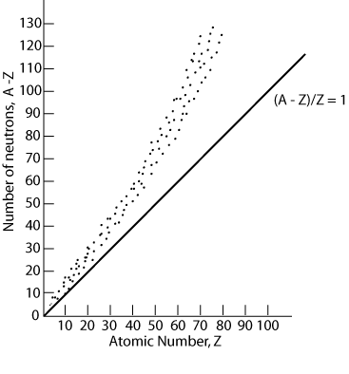

However, this strategy of adding neutrons to maintain stability only works if the nucleus has less than 84 p⁺. Bismuth () is the largest stable nucleus that exists (the graph above ends at Z=83)

Radioactive Decay

Beyond Bismuth, all nuclei are inherently unstable, and will eventually break apart. Smaller nuclei can also be radioactive, as many small nuclei isotopes are unstable due to too many or too few neutrons.
This process of breaking apart is called Radioactive Decay. There are several different forms of decay, and decaying nuclei usually go through several of them before finally turning into something stable.

Decay Types

Alpha decay (${}_{2}^{4}α$) – the spontaneous emission of a helium nucleus from a larger, unstable nucleus.
e.g. ${}_{88}^{226}{Ra}→{}_{86}^{222}{Rn}+{}_{2}^{4}{He}+energy$

Beta-negative decay (${}_{-1}^{0}{β^{-}}$) - a neutron is converted into a proton and a beta-negative particle (an electron) which is expelled from the nucleus.
e.g. ${}_{6}^{14}C→{}_{7}^{14}N+{}_{-1}^{0}{β^{-}}+energy$

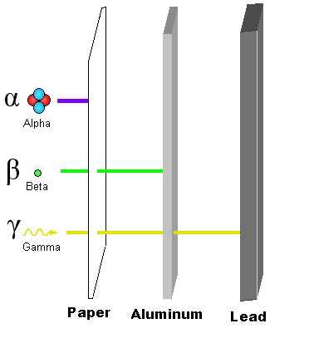
Beta-positive decay (${}_{1}^{0}{β^{+}}$) - a proton is converted into a neutron and a beta-positive particle (a positron) which is expelled from the nucleus.
e.g. ${}_{9}^{18}F→{}_{8}^{18}O+{}_{1}^{0}{β^{+}}+energy$

positron – a particle identical to an electron except that its charge is +1

Gamma decay (${}_{0}^{0}γ$) – a gamma particle is a high energy photon which is emitted when the nucleus is in an excited state. The nucleus does not undergo a transformation, but is less energetic.
e.g. ${}_{88}^{226}{{Ra}^{*}} → {}_{88}^{ 226}{Ra}+{}_{0}^{0}γ+energy$ * denotes excited
energy state

Radioactive Emissions 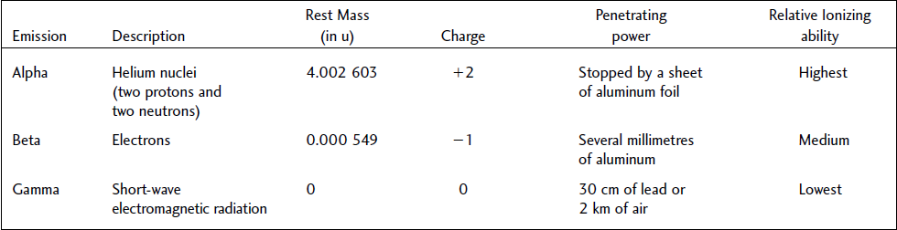

Radioactive Half-Life

Every radioactive isotope decays at a different rate. The time it takes for half of a sample of a radioactive material to decay is known as its half-life (T_{½}).

e.g. Carbon-14
Half-life of carbon-14 = 5730 years.

Time (a) | Amount Remaining (g)
0 | 1.0
5730 | 0.5
11460 | 0.25
17190 | 0.125  Etc...

Mathematically:
${N=N}_{0}{\left(\frac{1}{2}\right)}^{\frac{t}{t_{1/2}}}$ mass remaining (N)
initial mass (N_{o})
time passed (t)
half-life (T_{1/2})

RadioCarbon Dating

The carbon in carbon dioxide gas in the atmosphere is made up of all the isotopes of carbon that exist. The amount of each isotope in a sample of CO₂ depends on each isotope’s natural abundance. The natural abundance of carbon-14, for example, is 1 part in one trillion – so for every trillion CO₂ molecules, one will be one (C-14)O₂ molecule.

During the process of photosynthesis, carbon dioxide in the atmosphere is absorbed by plants and made into sugars that form their bodies. Animals (and other organisms) eat these plants and the carbon becomes part of their bodies too – this is how carbon becomes part of all living things. While a living thing is still alive and taking in new carbon from the atmosphere, the composition of carbon isotopes in its body will reflect carbon’s natural abundance. But when that living thing dies and stops acquiring new carbon, over time its carbon composition will change as radioactive forms of carbon (i.e. carbon-14) decay.

By knowing the natural abundance of radioactive carbon-14 (a value that changes over time – ice core and tree ring samples can help us determine abundances of years past) and the rate at which it decays time, we can determine the age of any living thing whose body has been preserved by measuring the amount of carbon-14 remaining in the sample.

e.g. For every 1.0 kg of carbon, there exists 1.0x10⁻⁹ g of carbon-14. How much carbon-14 should a 1 kg piece of wood have that is 20,000 year old?
N = ?
N_{o}= 1x10⁻⁹ g
t = 20000 a
T_{1/2}= 5730 a

${N=N}_{0}{\left(\frac{1}{2}\right)}^{\frac{t}{t_{1/2}}}$
$N=1x{10}^{-9}g{\left(\frac{1}{2}\right)}^{\frac{20000 a}{5730 a}}$

$N=8.9x{10}^{-11}g$

Nuclear Fission

Radioactive nuclei decay naturally and spontaneously but they can also be forced to do so by striking them with another nucleus, a sub-atomic particle, or a photon. Nuclear fission is the process intentional decay: splitting a massive nucleus into two (or more) less massive fragments (known as daughter nuclei)

In 1939, physicists realised that striking a Uranium-235 nucleus (${}_{92}^{235}U$, or simply, U-235) with a neutron would split it apart into several fragments, releasing energy

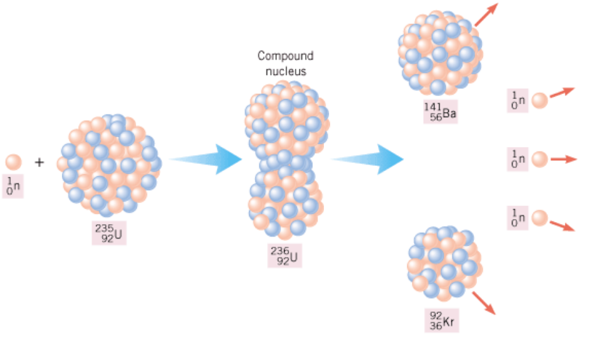
${}_{92}^{235}U+{}_{0}^{1}n→{}_{92}^{236}{U→}{}_{36}^{92}{Kr}+{}_{56}^{141}{Ba}+3{}_{0}^{1}n+energy$

Notice that after being struck by a neutron, the U-235 releases 3 more neutrons which then can react with other uranium atoms creating a chain reaction that can produce massive amounts of energy in under a microsecond. This chain reaction, or cascade effect, is the principle behind Nuclear Power.

Canadian CANDU reactors use natural uranium (mostly U-238) but can also run on other radioactive materials, including plutonium taken from old nuclear weapons, and used fuel rods from other nuclear plant designs. CANDU reactors use heavy water (D₂O – where D = ²H) to slow down neutrons so they can be more easily absorbed by the radioactive isotopes to initiate nuclear fission.

$${}_{92}^{238}U+{}_{0}^{1}n→{}_{92}^{239}{U→}{}_{93}^{239}{Np+{}_{-1}^{0}β}→{}_{94}^{239}{Pu+{}_{-1}^{0}β}→{}_{92}^{235}U+{}_{2}^{4}{He}$$

Energy in Nuclear Fission

So where does the energy from nuclear fission come from?

When a nuclear fission occurs, the total number of protons and neutrons before the reaction is the same as after the reaction – the total number of particles is conserved. However, if you were to compare the mass of the large nuclei before fission to the sum of the masses of all the smaller nuclei after fission, they will not be equal!
A violation of the law of conservation of mass? No!

Because the daughter nuclei are more stable than the parent, less energy is required to keep them together. A large nucleus needs a lot of energy to keep it together, which is stored in its mass! (To compare, the energy to keep a chemical compound together is stored in the chemical bonds keeping the atoms together). This means that the law of conservation of energy and the law of conservation of mass are actually the same law, since mass can be transformed into energy and energy into mass:

The Law of Conservation of Mass-Energy: The total mass-energy in an isolated system is constant.

It was Albert Einstein who first realised this relationship and from it came his most famous equation:
$$E=mc^{2}$$

This equation give you the amount of energy released when converting mass into pure energy, or, conversely, the amount of mass created when converting energy to mass. In terms of nuclear fission, however, the mass being converting is that of the difference between nuclear reactants and products. This difference is called the mass defect of the reaction, and this is what gives us the energy of nuclear fission.

For fission:
$$E=∆mc^{2}$$
E = energy released
Δm = mass defect
c = speed of light (2.998×10⁸ m/s)

e.g. Determine the amount of energy released when one U-239 nucleus undergoes nuclear fission (according to the following reaction):

$${}_{92}^{239}U+{}_{0}^{1}n→{}_{38}^{96}{Sr}+{}_{54}^{140}{Xe}+4{}_{0}^{1}n$$

Mass ${}_{92}^{239}U=239.052157 u$
Mass ${}_{0}^{1}n=1.008665 u$
Mass ${}_{38}^{96}{Sr}=95.921750 u$ * u = atomic mass unit
Mass ${}_{54}^{140}{Xe}=139.910581 u$ 1 u = 1.660538782×10⁻²⁷ kg

$$∆m=\left(m_{U}+m_{n}\right)-\left(m_{Sr}+m_{Xe}+4m_{n}\right)$$
$$∆m=239.052157 u+1.008665 u-95.921750 u-139.910581 u-4\left(1.008665 u\right)$$
$∆m=\left(0.193831 u\right)×\left(1.660538782×{10}^{-27}\frac{kg}{u} \right)$
$∆m=3.21864×{10}^{-28} kg$

$$E=∆mc^{2}$$
$$E=\left(3.21864×{10}^{-28} kg\right)×{\left(2.998×{10}^{8} m/s\right)}^{2}$$
$E=2.893×{10}^{-11} J$
So, 2.893×10⁻¹¹ J of energy is released from a single U-239 nucleus, which at first does not seem like very much. However, in a 1.0 g sample of U-239, there are approximately 2.519×10²¹ nuclei, so if the entire sample where to undergo fission:

$$E=\left(2.89291×{10}^{-11}\frac{J}{nuclei} \right)\left(2.519×{10}^{21} nuclei\right)$$
$E=7.287×{10}^{10} J$ And that IS a lot of energy!

Mega Electronvolts (MeV)

Using joules when studying energy per reaction yields awkward numbers to work with (see example above), so nuclear physicists use the mega electronvolt (MeV) (as a chemist uses mols, an astrophysicist used lightyears, etc).
1 MeV = 1.602×10⁻¹³ J
We can also simplify Einstein’s equation by knowing the energy equivalent of one atomic mass unit (u):
$$E=mc^{2}$$
$$E=\left(1.66×{10}^{-27} kg\right)×{\left(2.998×{10}^{8} m/s\right)}^{2}×\frac{1 MeV}{1.602×{10}^{-13}J }$$
$E=930 MeV$

So:
$$E=mc^{2}$$
$$930 MeV=\left(1 u\right)×c^{2}$$
$c^{2}=930 {MeV}/u$

To redo the above example using these units:

$${}_{92}^{239}U+{}_{0}^{1}n→{}_{38}^{96}{Sr}+{}_{54}^{140}{Xe}+4{}_{0}^{1}n$$

Mass ${}_{92}^{239}U=239.052157 u$
Mass ${}_{0}^{1}n=1.008665 u$
Mass ${}_{38}^{96}{Sr}=95.921750 u$
Mass ${}_{54}^{140}{Xe}=139.910581 u$

$$∆m=\left(m_{U}+m_{n}\right)-\left(m_{Sr}+m_{Xe}+4m_{n}\right)$$
$$∆m=239.052157 u+1.008665 u-95.921750 u-139.910581 u-4\left(1.008665 u\right)$$
$∆m=\left(0.193831 u\right)$

$$E=∆mc^{2}$$
$$E=\left(0.193831 u\right)×\left(930 {MeV}/u\right)$$
$E=181 MeV$

Nuclear Fusion

Nuclear fission is able to provide energy because the daughter nuclei are more stable (require more energy to break apart) than the parent. By looking at the amount of energy required to break apart a nucleus (binding energy), the most stable nuclei that exist turns out to have around 55 total nucleons (i.e. Iron).
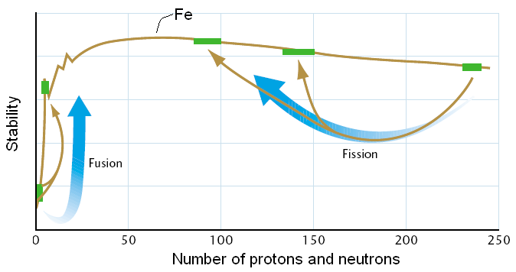

This means that taking two small nuclei and putting them together to make a larger, more stable, nucleus will also create a mass defect, where the total mass of the smaller nuclei at the start will be more than the mass of the new, larger nucleus. Just like fission, the mass defect leads to a release of energy, except that, in general, the mass defect (and energy released) per reaction is much larger.

The process of taking two small, unstable nuclei and fusing them together to make a larger more stable nucleus is called Nuclear Fusion.

e.g. Determine the amount of energy released when one
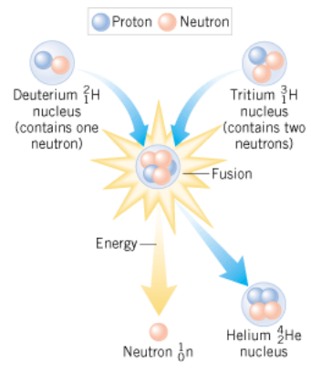
Deuterium nucleus (${}_{1}^{2}H$) and one Tritium nucleus (${}_{1}^{3}H$) are
fused together, making a Helium nucleus (${}_{2}^{4}{He}$):

${}_{1}^{2}H+{}_{1}^{3}H→{}_{2}^{4}{He}+{}_{0}^{1}n+{}_{0}^{0}γ$

Mass ${}_{1}^{2}D=2.014102 u$
Mass ${}_{1}^{3}T=3.016049 u$
Mass ${}_{2}^{4}{He}=4.002602 u$
Mass ${}_{0}^{1}n=1.008665 u$

$$∆m=\left(m_{D}+m_{T}\right)-\left(m_{He}+m_{n}\right)$$
$$∆m=2.014102 u+3.016049 u-4.002602 u-1.008665 u$$
$∆m=0.018884 u×\left(1.660538782×{10}^{-27}\frac{kg}{u} \right)$
$∆m=3.3158×{10}^{-29} kg$

$$E=∆mc^{2}$$
$$E=\left(3.3158×{10}^{-29} kg\right){\left(2.998×{10}^{8}m/s\right)}^{2}$$
$$E=2.818×{10}^{-12} J$$

So, for 1.0 g of reactants (deuterium and Tritium), there are approximately 1.204×10²³ nuclei, so if the entire sample where to undergo fusion:

$$E=\left(2.818×{10}^{-12}\frac{J}{nuclei} \right)\left(1.204×{10}^{23} nuclei\right)$$
$E=3.393×{10}^{11} J$ A reaction about 4 times more energetic as fission!

Fusion, Stars and the Elements

Even though more energy per mass is released during fusion, it is much harder to get nuclei to fuse together as nuclei contain protons, and protons repel. As a result, these nuclei must have very high kinetic energy (high temperature) on their own to fuse. To obtain these required energies on earth does not seem to be possible (though scientists are trying to get around it – try looking into Cold Fusion), the environment inside stars (and our sun) is ideal – once fusion starts, the energy released allows remaining nearby nuclei to fuse as well, which sustains the reaction. This is where many smaller nuclei come from:

e.g. Helium from Hydrogen in a star (*recall, Hydrogen came very soon after the Big bang)
$${}_{1}^{1}H+{}_{1}^{1}H→{}_{1}^{2}H+{}_{1}^{0}{β^{+}} \\ {}_{1}^{2}H+{}_{1}^{1}H→{}_{2}^{3}{He} \\ {}_{2}^{3}{He}+{}_{2}^{3}{He}→{}_{2}^{4}{He}+2{}_{1}^{1}H$$

Similarly, Carbon can be made from 3 Helium nuclei, Nitrogen from Carbon and Hydrogen, Fluorine from nitrogen and helium, and all kinds of other interesting combinations. But fusion only releases energy when making elements as large as Iron, as larger nuclei are less stable and take energy away when formed (This is why Iron is found at the core of many stars and planets... like earth!)

When this happens, less and less energy is available for fusion, so the stars cools and gravitational forces can soon dominate, causing the star to a collapse into itself. During this collapse, extremely high temperatures are created (like in a supernova), the energy released is able to create the elements larger than iron. Once the star finally dies, it spews out all of these elements into outer space to become part of other stars, planets, and the rest of the tangible stuff in the universe.

Everything in the universe, including ourselves, have not only have come from stars but is a direct result of nuclear reactions!

