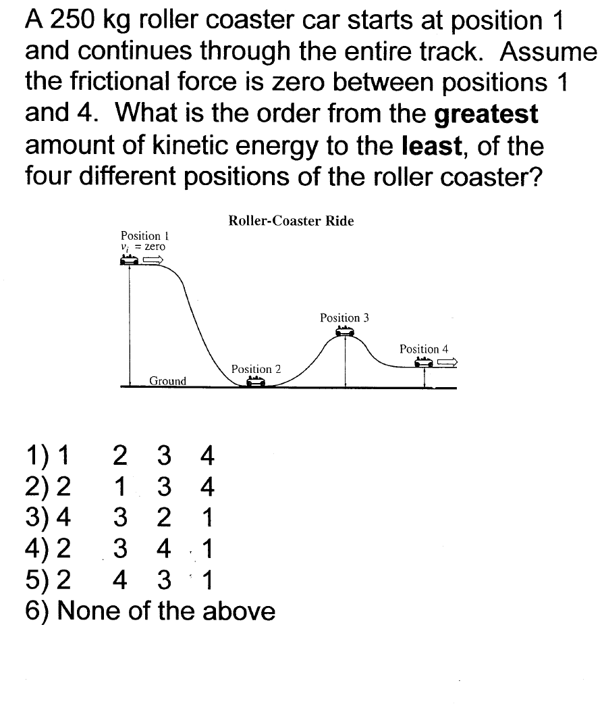















Draw an Energy-Bar diagram for each picture of the ball.

3.a)Draw energy-bar diagrams for the ball at positions A, B and C (assume no friction)



b) i)Draw the energy- bar diagram for the ball at position B if there was friction and the ball lost 15% of its mechanical energy between A and B

ii) Calculate the speed of the ball at point C if the mass of the ball is 500 g.