The Seven Cases of Motion



1. Object at Rest





2. Constant velocity,

positive direction



3. Constant velocity,

negative direction



4. Speeding up,

positive direction



**

5. Speeding up,

negative direction



6. Slowing down,

positive direction

**

7. Slowing down,

negative direction

**

**Position vs Time Graphs:**

1. Describe the motion below:

1. auto is at rest (at a stoplight?)

2. auto speeds up in negative direction (heading west?)

3. auto moves at a constant, negative velocity

4. auto slows down to a stop (another stoplight?)

5. auto remains at rest

1. Sketch a position vs time graph for the following motion (consider up to be positive):
2. A ball falls downwards due to gravity
3. As it hits the ground, it quickly slows down, stops, then accelerates upwards
4. As it travels back upwards it slows down to rest at the max height of its bounce
5. Then falls back to the ground, decelerates to rest, and remains at rest.

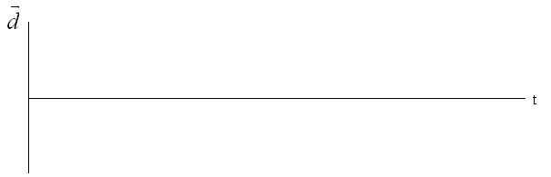

1. a) Calculate the instantaneous velocity at 1, 2, 4, and 8 seconds on the graph below



At 1.0 s:

$\overset{⃑}{v}=\frac{2.0 m-1.0 m}{1.0 - 0.0 s}$

$\overset{⃑}{v}=1.0 m/s [fwd]$

At 8.0 s:

$\overset{⃑}{v}=\frac{5.25 m-5.0 m}{9.5 s-8.0 s}$

$\overset{⃑}{v}=0.17 m/s [fwd]$

At 4.0 s:

$\overset{⃑}{v}=\frac{4.75 m-3.0 m}{6.0 s-2.0 s}$

$\overset{⃑}{v}=0.44 m/s [fwd]$

At 2.0 s:

$\overset{⃑}{v}=\frac{3.5 m-1.5 m}{3.0 s-0.0 s}$

$\overset{⃑}{v}=0.67 m/s [fwd]$

1. 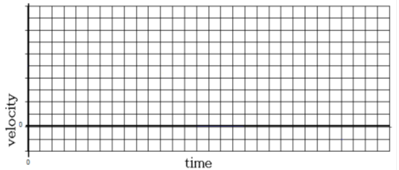Using the four instantaneous velocities calculated in Q4, construct a velocity vs time graph

1.0

0.5

8.0

6.0

5.0

4.0

3.0

2.0

1.0

Note: IB would want you draw a curve of best fit



1. Describe the motion of each labelled section of the graph above.

A – speeding up moving East

B – constant velocity, moving East

C – slowing down to rest, moving East

D – at rest

E – speeding up, moving West

F – speeding up at a faster rate, moving West

G – slowing down, moving West

1. Calculate to total displacement of the human's motion.

$∆\overset{⃑}{d}=\frac{1}{2}\left({\overset{⃑}{v}}_{1} +{\overset{⃑}{v}}_{2}\right)\left(∆t\right)$

$∆{\overset{⃑}{d}}_{A}=\frac{1}{2}\left(5 m/s +8 m/s\right)\left(2s\right)=13 m$

$∆{\overset{⃑}{d}}_{B}=\left(8 m/s\right)\left(2s\right)=16 m$

$∆{\overset{⃑}{d}}_{C}=\frac{1}{2}\left(8 m/s\right)\left(3s\right)=12 m$

$∆{\overset{⃑}{d}}_{D}=\left(0 m/s\right)\left(2s\right)=0 m$

$∆{\overset{⃑}{d}}_{E}=\frac{1}{2}\left(-1 m/s\right)\left(2s\right)=-1 m$

${∆\overset{⃑}{d}}_{F}=\frac{1}{2}\left(-1 m/s +\left(-7 m/s\right)\right)\left(2s\right)=-8 m$

$∆{\overset{⃑}{d}}_{G}=\frac{1}{2}\left(-7 m/s +\left(-5 m/s\right)\right)\left(2s\right)=-12 m$

$∆{\overset{⃑}{d}}_{total}=13 m+16 m+12 m+0 m-1 m-8 m-12 m$

$∆{\overset{⃑}{d}}_{total}=20 m [E]$

1. Calculate the acceleration of the human for each section of the graph.

$\overset{⃑}{a}=\frac{∆\overset{⃑}{v}}{∆t}$

${\overset{⃑}{a}}_{A}=\frac{8 m/s -5 m/s}{2 s-0s}=1.5 m/s^{2}$

${\overset{⃑}{a}}_{B}=\frac{8 m/s -8 m/s}{4 s-2 s}=0 m/s^{2}$

${\overset{⃑}{a}}_{C}=\frac{0 m/s -8 m/s}{ 7 s-4 s}=-2.7 m/s^{2}$

${\overset{⃑}{a}}_{D}=\frac{0 m/s -0 m/s}{ 9 s-7 s}=0 m/s^{2}$

${\overset{⃑}{a}}_{E}=\frac{-1 m/s -0 m/s}{ 11 s-9 s}=-0.5 m/s^{2}$

${\overset{⃑}{a}}_{F}=\frac{-7 m/s -\left(-1 m/s\right)}{ 13 s-11 s}=-3 m/s^{2}$

${\overset{⃑}{a}}_{G}=\frac{-5 m/s -\left(-7 m/s\right)}{ 15 s-13 s}=1 m/s^{2}$

1. How far did the human move in the west direction?

$d_{West}=1 m+8 m+12 m$

$d_{West}=21 m$

1. What is the highest speed obtained?

$v_{max}=8 m/s$

1. Which section of the graph has the highest magnitude of acceleration?

Section F

1. What does the section of the graph under the t axis mean?

Motion in the West direction

1. At what times is the velocity zero?

From $t=7 s$ to $t=9 s$

1. At what times is the velocity constant and non-zero?

From $t=2 s$ to $t=4 s$

1. Does the human return to its starting point? Explain.

No, since its total displacement is non-zero (i.e. the human travelled 20 m [E] of its starting point).

1. Sketch a position vs time of the above motion, on the graph below.

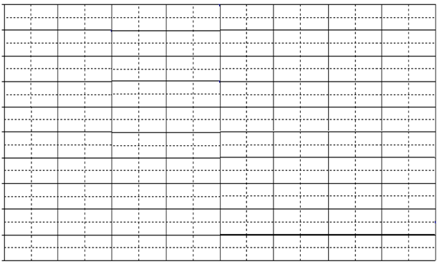

Position

(m [E])

**25**

**Time (s)**

**0 2 4 6 8 10 12 14**

**20**

**15**

**10**

**5**

**45**

**40**

**35**

**30**

1. A rocket is launched into the air and then runs out of fuel. Its motion is graphed below



A

C

B

D

E

G

F

Notes: - Single letters represent a points (e.g. ***C***), Two letters represent a line (e.g. ***CD***) and three letters represent an area (triangle) (e.g. ***AbC***)

Which letter(s) represents each of the following?

|  |  |  |
| --- | --- | --- |
| a | time of maximum height | **D** |
| b | acceleration of the rocket caused by its engine | **AC** |
| c | the maximum velocity | **E** |
| d | the distance travelled while the rocket burns its fuel | **ABC** |
| e | the depth of the hole created when the rocket hits the ground | **EFG** |
| f | the time the rocket strikes the ground | **F** |
| g | the acceleration as the rocket falls back to earth | **CE** |
| h | the distance travelled from maximum height to the ground | **DEF** |



1. Create a velocity vs time graph for the following data of a student walking through a packed hallway. Also find the acceleration for the following intervals: 0-2 s, 2-4 s, 4-6 s, 6-9 s, 9-12 s.

|  |  |  |  |  |  |
| --- | --- | --- | --- | --- | --- |
| time (s) | velocity (m/s) | time (s) | velocity (m/s) | time (s) | velocity (m/s) |
| 0 | 1.0 [right] | 5 | 3.0 [right] | 10 | 3.5 [left] |
| 1 | 1.0 [right] | 6 | 3.0 [right] | 11 | 4.0 [left] |
| 2 | 1.0 [right] | 7 | 1.0 [right] | 12 | 4.5 [left] |
| 3 | 2.0 [right] | 8 | 1.0 [left] |  |  |
| 4 | 3.0 [right] | 9 | 3.0 [left] |  |  |

