Physics IB 12
Simple Harmonic Motion Problems

Starting Points:
F_{s} = -k∆x (Hooke’s Law; the force is a “restoring force”)
Amplitude (A): maximum displacement from equilibrium or rest position (m)
Period (T): time to complete one cycle or motion 9s)
Frequency (f): # of cycles (motions) per sec (Hz = Hertz)
F = -kx and F = ma
-kx = ma
a = -kA/m (at maximum stretch)

a = -kx/m (at any distance, x)
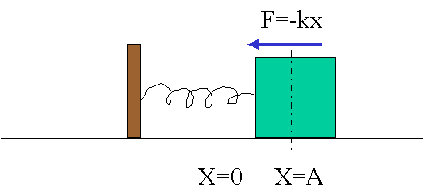

The back and forth motion of the mass is called Simple Harmonic Motion (SHM). A graph of position of the mass vs time is sinusoidal in nature and is shown below. A graph of velocity of the mass vs time is also sinusoidal in nature as shown below:

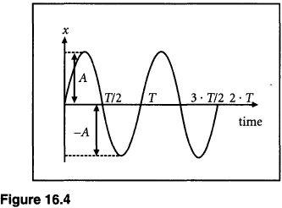
Examine the graph and the image of the mass shown earlier and convince yourself how the 2 are related.

Kinematics of Simple Harmonic Motion
The following graph shows the position vs time graph for SHM:
Two equations that can describes this motion are:
Position is a cosine function:
x(t) = A cos (2πt/T)
Velocity is a Sine function:
v_{x} = -v_{max} sin (2πt/T)
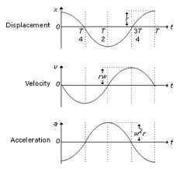

From previously: 2πf = 2π/T = ω (angular velocity) and:
x(t) = A cos (ωt) & v_{x} = -v_{max} sin (ωt)
And that:
v_{max} = 2π/T = 2πf = ωA (which occurs when position x = A)
Example 1
An air-track glider is attached to a spring pulled 20 cm to the right and released at t = 0. It makes 15 oscillations in 10 s.
- What is the period and frequency of oscillation?
T = 10 s /15 = 0.667 s & f = 15/10 s = 1.5 Hz
- What is the objects maximum speed?
v_{max} = 2πA/T = 2π(0.20 m)/0.667 s = 1.88 m/s
- What are the position and velocity at t = 0.80 s? (Note: Must use radians in cos and sine calc)
Position: x(t) = A cos (2πt/T); x = 0.20 m(cos (2π0.80 s)/0.667 s) = 0.062 m
Velocity: v_{x} = -v_{max} sin (2πt/T); v_{x} = -1.88 m/s sin (2π0.80 s/0.667 s) = - 1.79 m/s

Example 2
A mass oscillating in simple harmonic motion starts at x = A and has period T. At what time, as a fraction of T, does the object first pass through x = ½ A?
x(t) = A cos (2πt/T); x = (A/2) = A cos (2πt/T);
now solve for the time at which this position is reached:
t = (T/2π) cos⁻¹ (1/2) = (T/2π)( π/3) = (1/6) T

Simple Harmonic Motion and Circular Motion
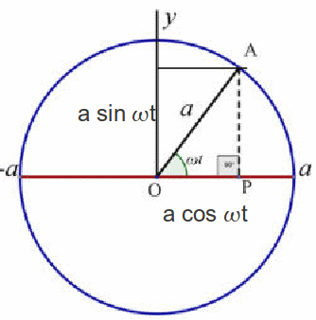

A

θ
A
-A
θ
x = A

A ball at the end of a string travelling in a vertical circle will project a shadow onto the x-axis as shown. The shadow will only move back and forth exhibiting SHM.

The displacement on the x-axis as the ball moves in this circle is given by: x = A cos θ.

Starting Point: x = A cos θ but remember ω = θ/t and θ = ωt
x = A cos ωt and ω = 2π/T
x = A cos (2π/T) t or x = A cos (2πt/T)
Which is the same as the equation for position for simple harmonic motion!

Energy in Simple Harmonic Motion
Potential Energy in a spring: U = ½ kx²
Kinetic Energy: E_{k} = ½ mv²
Total Energy: E_{T} = E_{k} + U
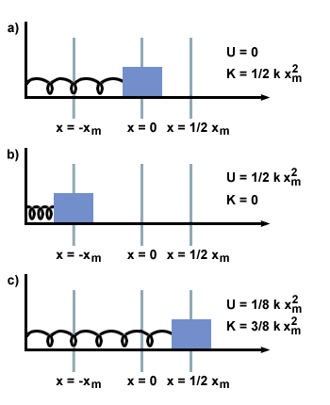
At some displacement, x = ½ x_{m};
E_{T} = U + E_{k} = ½ kx_{m}² + ½ mv_{x}²

At maximum displacement, x = -A;
E_{T} = U = ½ kx² (E_{k} = 0)

At minimum displacement, x = 0;
E_{T} = E_{k} = ½ mv_{max}² (U = 0)

Since the system’s mechanical energy is conserved (no energy is lost due to friction):
E_{T} = E_{k} + U = ½ mv_{x}² + ½ kx²
At maximum displacement (x = + A) all the energy is all potential:
U (at x = + A) = ½ kx² = ½ kA²
At the mid-point (x = 0 & v_{x} = + v_{max}) all the energy is kinetic:
E_{k} (x = 0) = ½ mv_{max}²
Since energy is conserved the energy at maximum and minimum must be the same, and hence:
E_{k} = U
1/2mv_{max}² = 1/2kx² = 1/2kA² (and x = A at maximum displacement)
v_{max}² = (k/m) A²
v_{max} = √(k/m) A
Remember from SHM: v_{max} = 2πA/T = 2πAf = ωA
Therefore: √(k/m) A = ωA
And ω = √(k/m)
Since T = 2 πω and f = (1/2 πω)
T = 2 π √(m/k) & f = (1/2 π) √(k/m)
Because energy is conserved we can write:
ET = 1/2mv_{x}² + 1/2kx² = 1/2kA² = 1/2mv_{max}²
Any pair may be useful, depending on the known information:
For example, you can use the amplitude A, to find the speed at any point x by combining the first and second expression:
v = √K/m(A² – x²) = ω √(A² – x²)
Or you can use the first and second expression to find the amplitude from the initial conditions x_{o} and v_{o}:
A = √(x_{o}² + mv_{o}²/k) = √(x_{o}² + v_{o}²/ ω); (ω = √k/m )
Example 3
A 500 g block on a spring is pulled a distance of 20 cm and released. The subsequent oscillations are measured to have a period of 0.80 s. At what position or positions is the block’s speed 1.0 m/s?
Solution: Energy is conserved!
1/2mv_{x}² + 1/2kx² = 1/2kA²
Solving for x:
½ mv_{x}² + ½ kx² = ½ kA²
mv_{x}² + kx² = kA²
kx² = kA² - mv_{x}²
x² = (kA²/k) – (mv_{x}²/k)
x² = (A²) – (mv_{x}²/k)
x = √(A² – mv_{x}²/k) = √(A² – (v_{x}/ ω) ²) (where k/m = ω²)
and ω = 2π/T = 2π/0.80 s = 7.85 rad/s
x = √(0.20² – (1.0/7.85)²) = + 0.154 m

Stop and Think Questions:
This is the position vs time graph of a mass on a spring. The mass is pulled back a distance of 10 m and then let go.
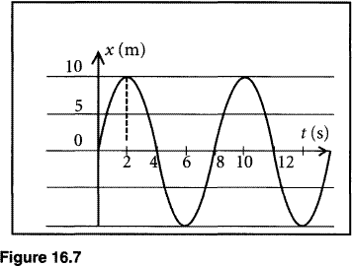

- What is the position of the mass at the dotted line?
- Is the velocity of the mass a maximum or minimum at this position?
- What direction is the force acting on the spring at this point?
- State a time that the mass would have a maximum speed?
- State a time where the mass would have a maximum potential energy?
- State a time where the mass would have a minimum potential energy?
- State a time where the mass would have a maximum kinetic energy?
- State a time where the mass would have a minimum kinetic energy?
- Calculate the period and frequency of the mass?
- Use ω = 2πf = √(k/m) to determine the spring constant for this mass of 3.0 kg.

Vertical Oscillations
A spring is hung vertically from a ceiling. When a mass is added to that spring and pulled down and released simple harmonic motion results.
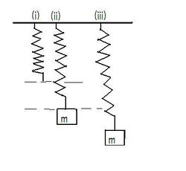
Since the mass is not moving (is at equilibrium) at (ii):
F_{g} = F_{s}
mg = k∆L
∆L = mg/k

F_{s}
∆L

Pull the mass down further (iii) and then let the mass move; it will oscillate up and down in simple harmonic motion. The displacement, y, of the mass is described by the exact same equation shown before:
y (t) = A cos ωt;
where ω = 2πf = √(k/m)
F_{g}

Example 4
A 200 g block hangs stationary from a spring pulling the spring downwards a distance of 19.6 cm. The block is then pulled down a distance of 30 cm and released. Where is the block and what is its velocity 3.0 s later?
Solution:
Find k: k = mg/∆L = 0.200 kg x 9.8/0.196 m = 10 N/m
y (t) = A cos ωt = A cos (√(k/m))t = 10.4 cm cos (√(10/0.200)) x 3.0
y = -7.4 cm (above the equilibrium position) (ω = (√(k/m = 7.07 rads)
v_{x} = ωA sin(ωt) = 7.07 x 10.4 x sin (7.07 x 3.0) = 52 cm/s (ω = (√(k/m = 7.07 rads)
The Pendulum
A mass hanging from a string attached to a ceiling makes a very good oscillator.
Free-Body Diagram for the mass, m:
F_{T}
Ø
L

W_{t}
m
s
Arc length
W_{t} = mg sin Ø
(component of gravity force)

Ø = s/L
F_{g}

Therefore: net force = F_{net} = mg sin Ø and since ma = mg sin Ø & a = g sin Ø

For small angles of Ø there is an approximation that works really well:
When using radians: s = r sin Ø ≈ r Ø (sin Ø ≈ Ø) (good for up to 0.10 rad (10º)
s = r Ø
r
Ø
h = r sin Ø

l = r cos Ø

Sin Ø ≈ Ø = s/L (r = L)
The angular frequency, ω = 2πf = √g/L
And therefore frequency and period for a pendulum would be:
f = 1/2π √g/L and T = 2π√L/g

Example 5
What length and mass of a pendulum has a period of exactly 1 s?
Solution: Mass can be any value!
T = 2π√L/g therefor: L = g (T/2 π)² = 9.80 (1.0/2 x 3.14)² = 0.248 m

