TOPIC: 4
Oscillation and waves
4.1 Simple harmonic motion – Worksheet - Answers

- A particle undergoes SHM with amplitude of 4.0mm and angular frequency of 2.0 s⁻¹. At t = 0, the displacement is 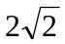mm. Write down the equation of displacement for this motion.
ANSWERS: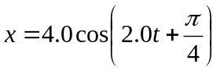
- A particle undergoes SHM with amplitude of 8.00 cm and an angular frequency of 0.25 s⁻¹. At t = 0 the velocity is 1.24 cm s⁻¹.
(a) Write down the equation for displacement and velocity for this motion.
(b) Calculate the initial displacement.
(c) Calculate the first time at which the particle is at x = 2.00 cm and x = - 2.00 cm.
ANSWERS: (a) 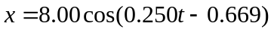, 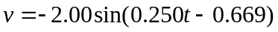
(b) 6.28 cm (c) t = 7.95s and t = 9.97 s
- (a) Calculate the length of a pendulum that has a period equal to 1.00s.
(b) Calculate the percentage increase in the period of a pendulum when the length is increased by 4.00%.
ANSWERS: (a) 0.248 m (b) t = 1.02 s
- When a body is immersed in a liquid of density ρ it experiences an upthrust given by 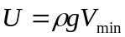 where 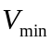 is the volume of the body immersed in the liquid. A rectangular body is floating in a liquid of density ρ. The body is pushed downwards by a distance A and is then released. Show that the body will perform simple harmonic oscillations, and find the period of motion.
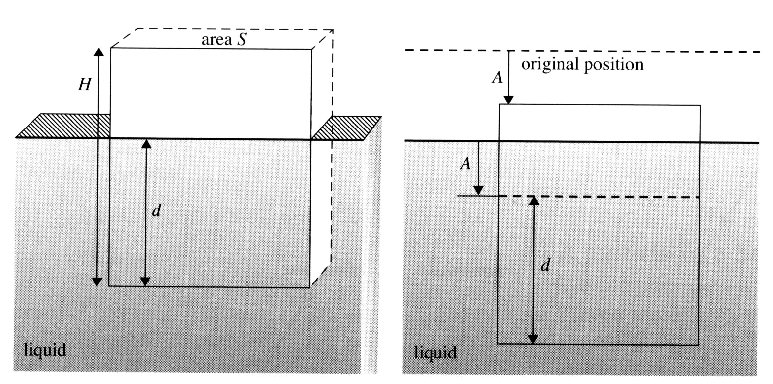
Answer: 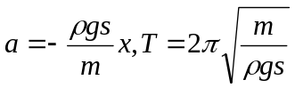
- The graph in the figure shows the variation with displacement x of the acceleration ‘a’ of the particle.
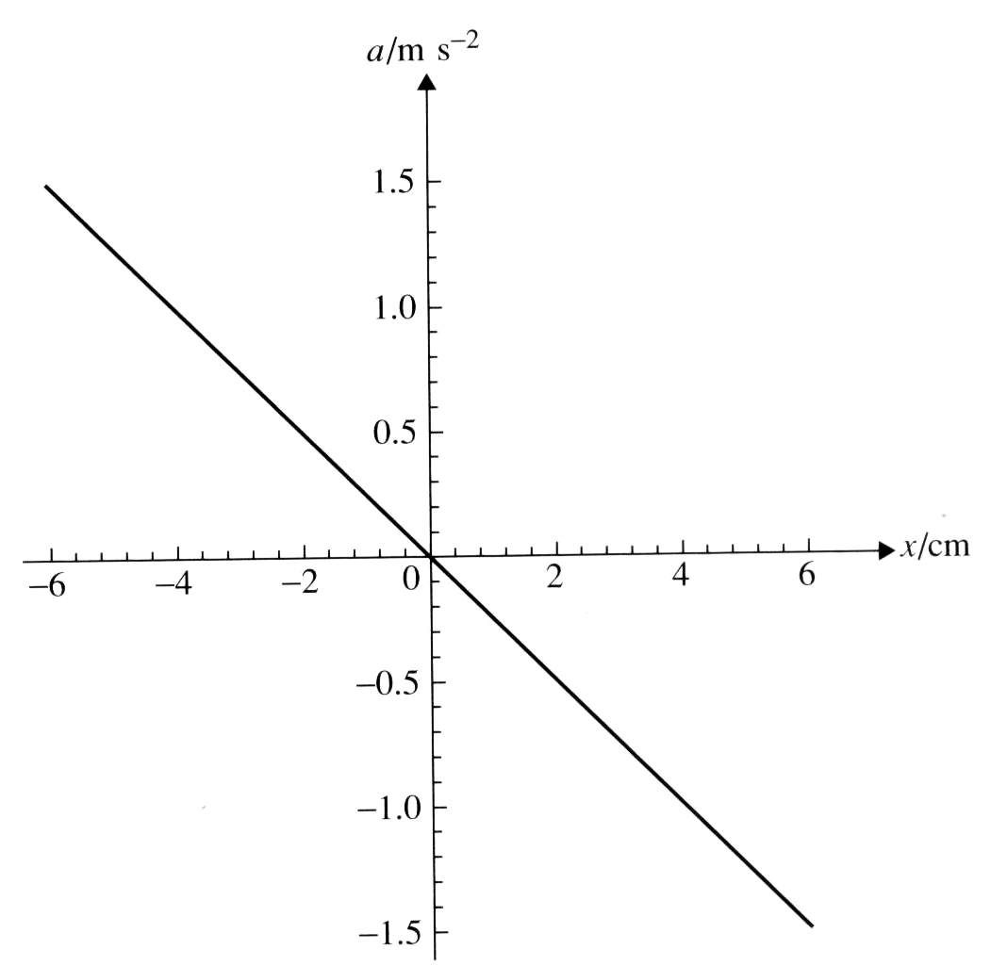

(a) Explain how it may be deduced that the particle executes SHM.
(b) Use the graph to determine the period of oscillations
(c) The maximum speed of the body during oscillations.
ANSWERS:(b) 5.0s (c) 0.30 ms⁻¹
- The graph in the figure shows the displacement of a particle from a fixed equilibrium position.
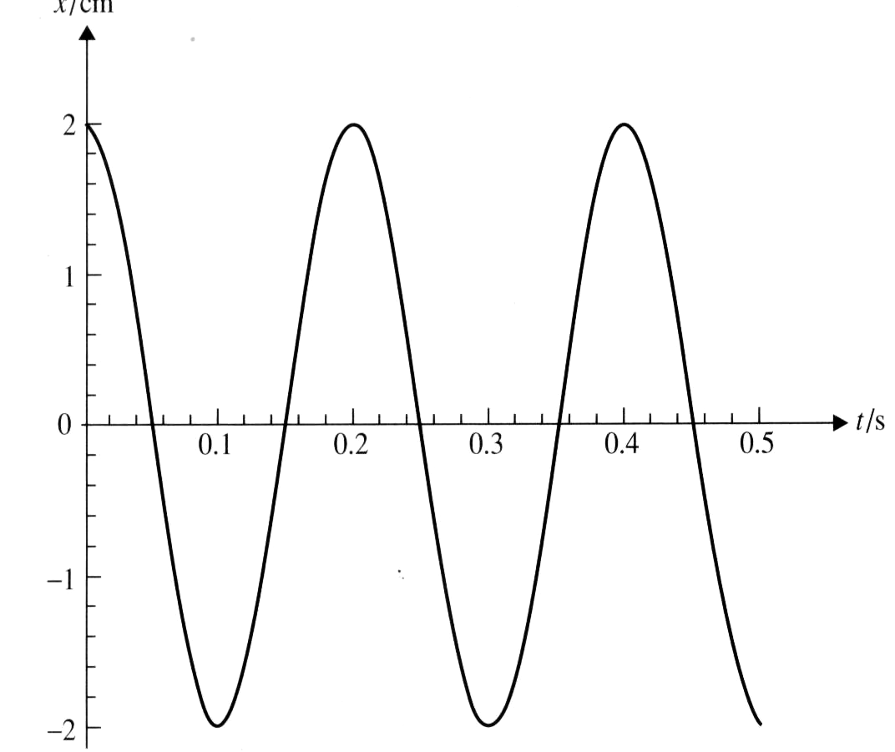
(a) Use the graph to determine: (i) the period of motion (ii) the maximum velocity of the particle during oscillation, and (iii) the maximum acceleration experienced by the particle.
(b) On a copy of the diagram, mark (i) a point where the velocity is zero ( label this as Z) (ii) a point where the velocity is positive and has the largest magnitude ( label this as V) (iii) a point where the acceleration is positive and has the largest magnitude ( label this as A). ANSWERS: (a) (i) 0.20 s (ii) 0.63ms⁻¹ (iii) 20ms⁻² (b) (i) extreme points (ii) t = 0.15s (iii) t = 0.10 s to t = 0.30 s
- A body of mass m is placed on a horizontal plate that under goes vertical SHM The amplitude of SHM is A and the frequency is f.
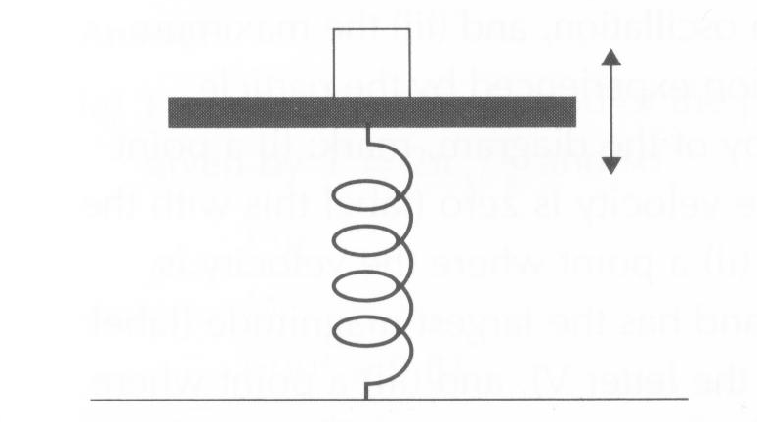
(a) Derive an expression for the reaction force on the particle from the plate when the particle is at its highest position.
(b) Using the expression in (a), deduce that the particle will lose contact with the plate if the frequency is higher than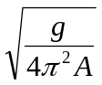.
ANSWERS: (a) 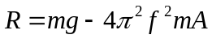(b) 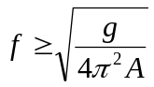
- The graph in the figure shows the variation with the square of displacement (x²) of the potential energy of a particle of mass 40 g that is executing SHM. Using the graph, determine :
(a) the period of oscillation
(b) the maximum speed of the particle during oscillation.

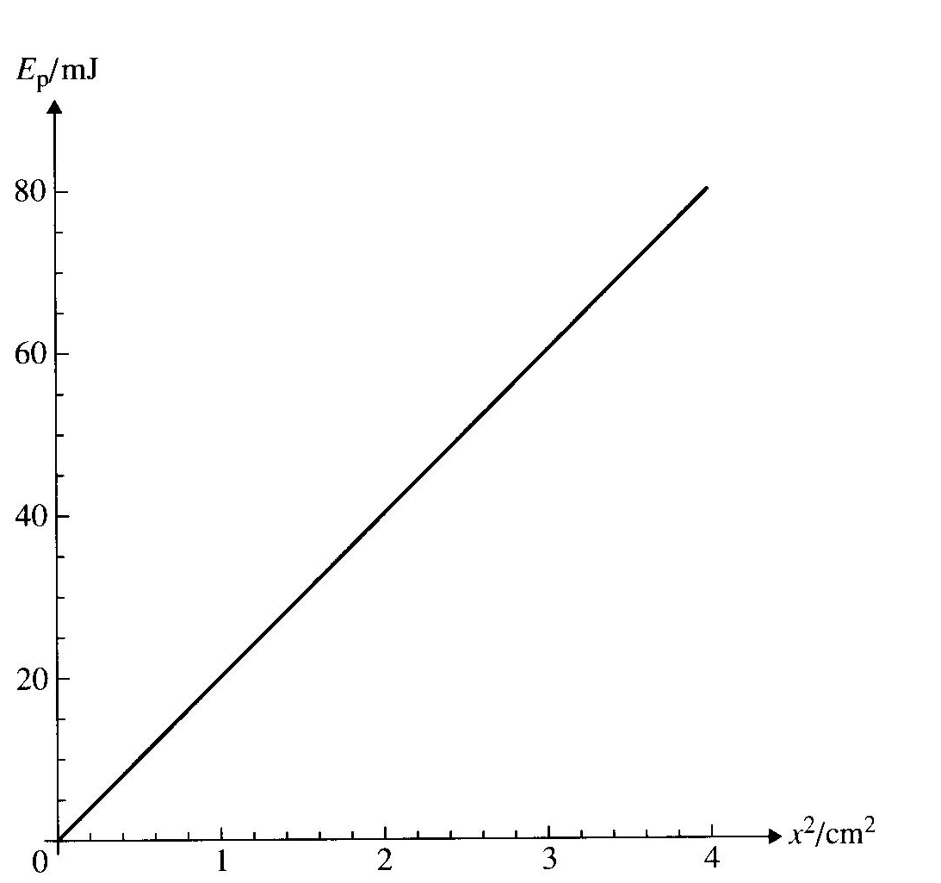
ANSWERS: (a) 100 s⁻¹, 6.28 x 10⁻²s (b) 2.00 ms⁻¹

- The graph in the figure shows the variation with displacement of the kinetic energy of a particle of mass 0.40kg performing SHM. Use the graph to determine
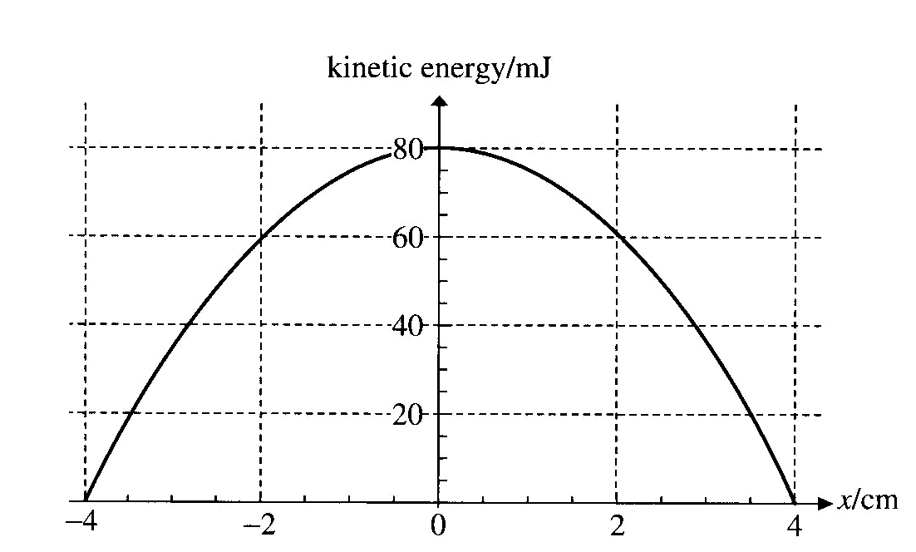
(a) the total energy of the particle
(b) the maximum speed of the particle
(c) the amplitude of motion
(d) the potential energy when the displacement is 2.0 cm
(e) the period of motion
ANSWERS: (a) 80 mJ (b) 0.63 ms⁻¹ (c) 4.0 cm (d) 20 mJ (e) T = 0. 40 s
- A particle of mass 0.50 kg undergoes SHM with angular frequency ω = 9.0 s⁻¹ and amplitude 3.0 cm. For this particle, determine:
(a) the maximum velocity
(b) the velocity and acceleration when the particle has displacement 1.5 cm and moves towards the equilibrium position from its initial position at x = 3.0 cm;
(c) the total energy of motion.
ANSWERS: (a) 0.27 ms⁻¹ (b)- 0.23 ms⁻¹, -1.2 ms⁻² (c) 18 mJ
- Show explicitly that, if if x = a cos(ωt +Ф), the period of motion is given by T = 2π/ω. Independently of A and Ф.
- The displacement of a particle executing SHM is given by y = 5.0 cos(2t), where y is in mm and t in seconds. Calculate
(a) the initial displacement of the particle;
(b) the displacement at t = 1.2s;
(c) the time at which displacement first becomes -2.0 mm;
(d) the displacement when the velocity of the particle is 6.0mm s⁻¹.
ANSWERS: (a) 5.0 mm (b) – 3.7 mm (c) 0.99s (d) 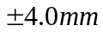
- (a) Write down the equation for the displacement of a particle performing SHM with an amplitude equal to 8.0 cm and frequency of 14 Hz, assuming that at t = 0 the displacement is 8.0 cm and the particle is at rest.
(b) Find the displacement, velocity and acceleration for this particle at a time of 0.025 s. ANSWERS: (a) 8.0 cos(28πt) (b) y = - 4.7 cm, v = - 5.7 ms⁻¹, a = 3.6 x 10² ms⁻²
- A point on a guitar string oscillates in SHM with amplitude of 5.0 mm and frequency 460 Hz. Determine the maximum velocity and acceleration for this point.
Answers: v = 14 ms⁻¹, a = 4.2 x 10⁴ ms⁻²
- A body performs SHM along a horizontal straight line between the extremes as shown in the figure.
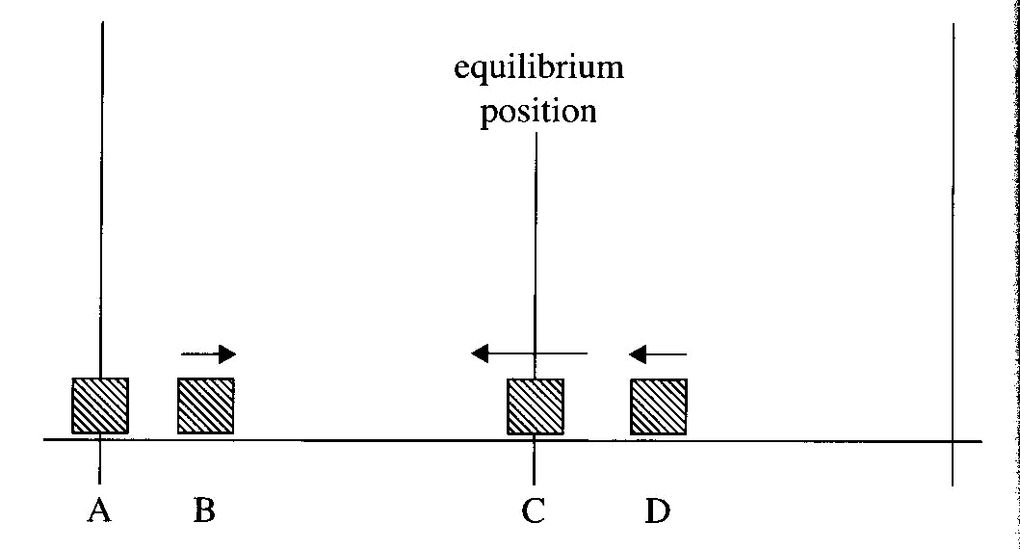
The arrows represent the direction of motion of the body. The body is shown in four positions A,B,C and D. Copy the diagram in each position, draw arrows to represent the direction and relative magnitude of (a) the acceleration of the body, and (b) the net force on the body.
Answers: A, right and along; B, right and shorter; C, zero; D,left and shortest

- The piston (of mass 0.25 kg) of a car engine has a stroke of 9.0 cm and operates at 4500 rev per minute as shown in the figure

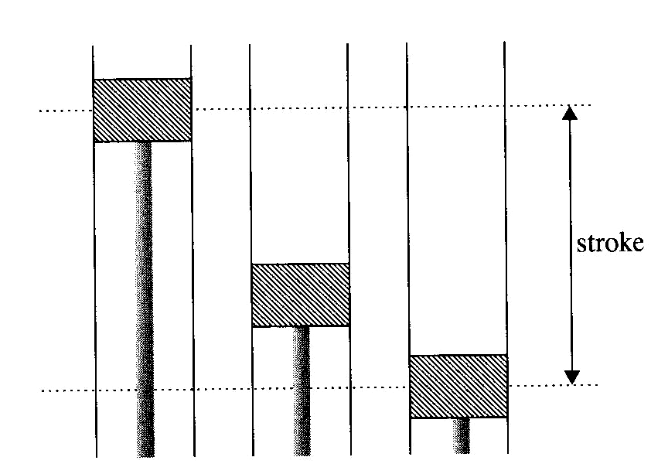
(a) Calculate the acceleration of the piston at maximum displacement
(b) Calculate the velocity as the piston moves past its equilibrium point,
(c) What is the net force exerted on the piston at maximum displacement?
Answers: (a) a = 1 x 10⁴ ms⁻² (b) v = 21 ms⁻¹, (c) F = 2.5 x 10³ N

- The graph in the figure shows the variation with time t of the velocity v of a particle executing SHM.
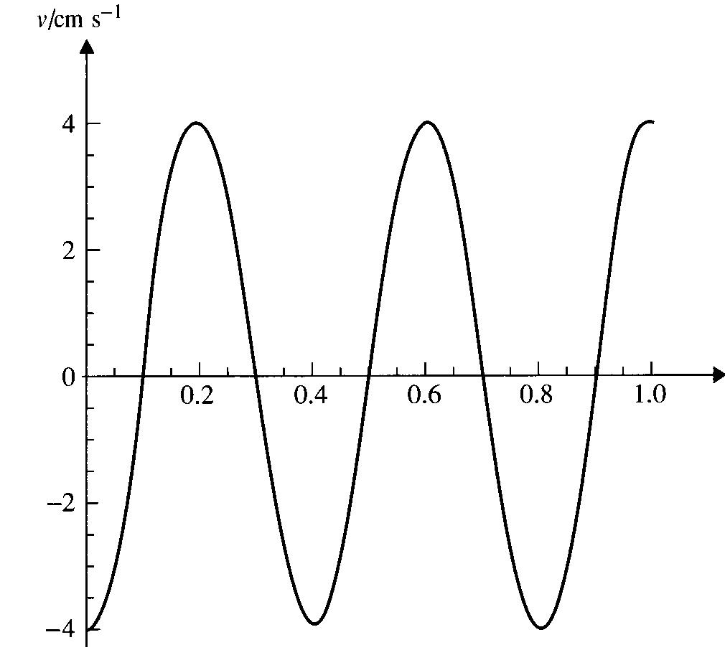
(a) Using the graph, estimate the area between the curve and the time axis from 0.10 s to 0.30s.
(b) state what this area represents.
(c) Hence write down an equation giving the displacement of the particle as a function of time.
Answers: (a) 0.51 cm; (b) twice the amplitude; (c) 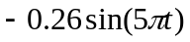

- The graph in the figure shows the variation with time t of the displacement x of a particle executing SHM.
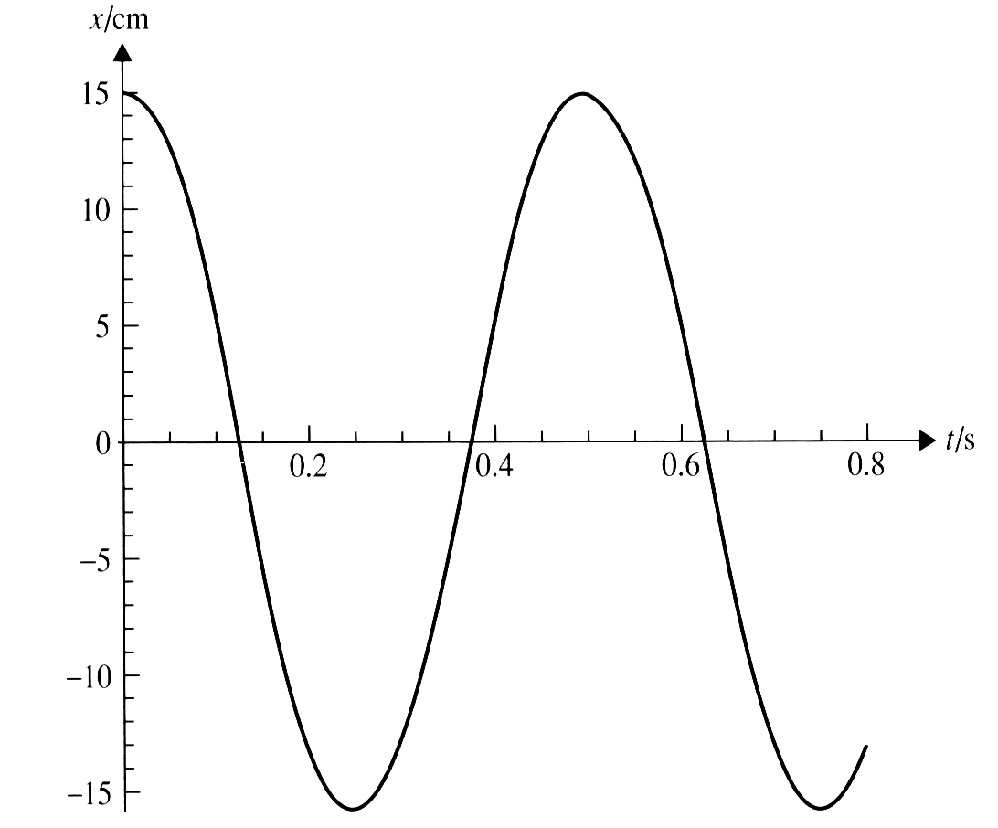
Draw a graph to show the variation with displacement x of the acceleration ‘a’ of the particle.
Answers:

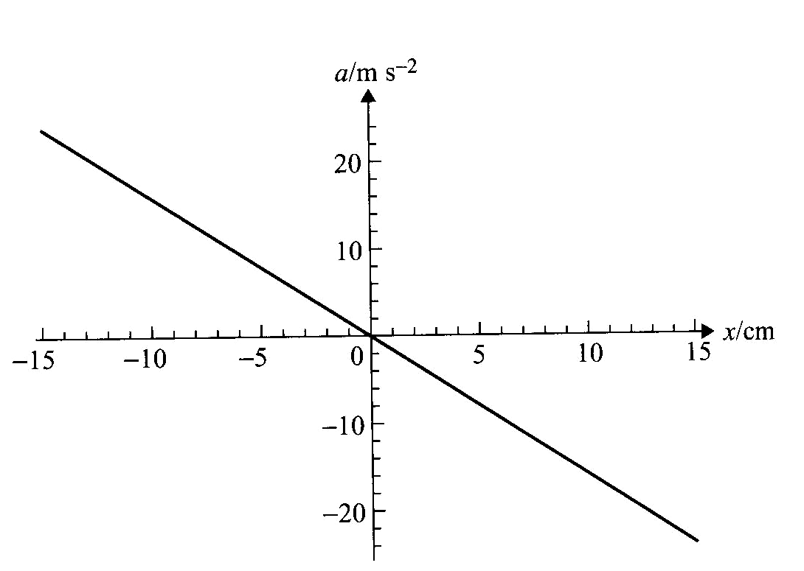

- The graph in the figure shows the variation with displacement x of the acceleration ‘a’ of a body of mass 0.150 kg

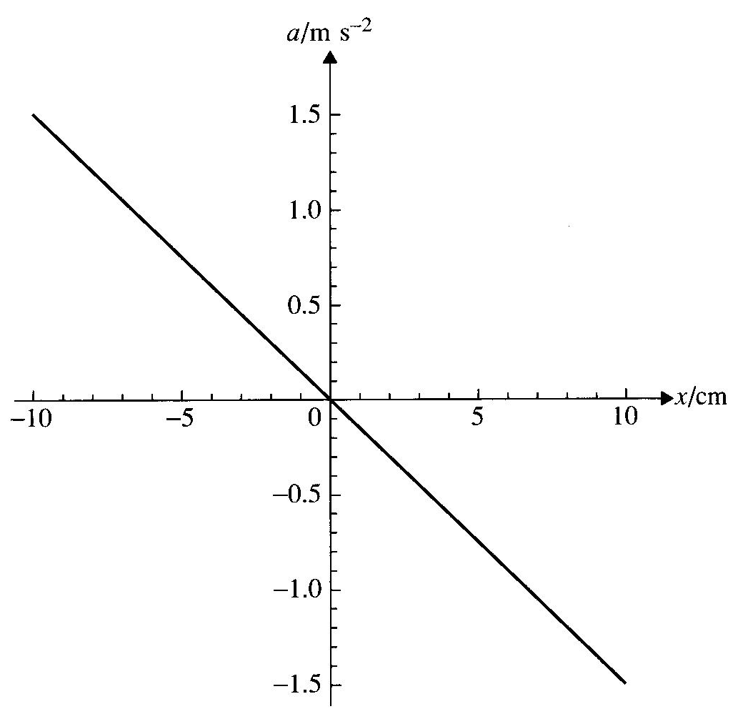

(a) Use the graph to explain why the motion of the body is SHM. Determine the following;
(b) the period of motion;
(c) the maximum velocity of the body during the oscillation.
(d) the maximum net force exerted on the body
(e) the total energy of the body
Answer: (b) 1.6 s (c) 0.40 ms⁻¹ (d) 0.24 N (e) 0.012J
- A body of mass 0.120 kg is placed on a horizontal plate. The plate oscillates vertically in SHM making 5 oscillations per second.
(a) Determine the largest possible amplitude of oscillations such that the body never loses contact with the plate.
(b) Calculate the normal reaction force on the body at the lowest point of the oscillations when the amplitude has a value found in (a).
ANSWER: (a) 9.94 mm (b) 2.35N

- A particle of mass ‘m’ is attached to the middle of a string of constant tension T. The length of the string is L. The tension on the string is so large that the string is essentially horizontal at the equilibrium position. The particle is displaced vertically by a small distance A and is then released.
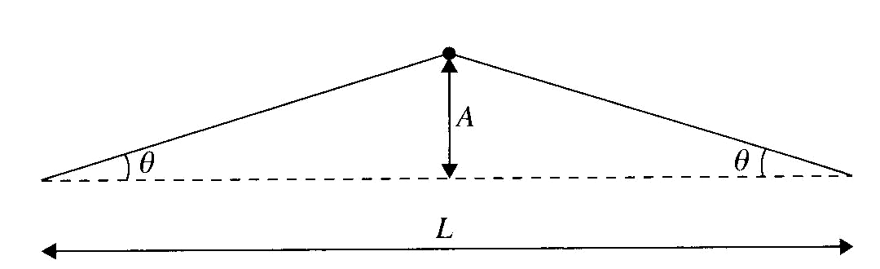
(a) Deduce that the net force on the particle at position shown is 2T sinθ.
(b) hence deduce that the particle’s acceleration is given by 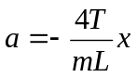, where x is the vertical displacement of the particle from the horizontal line.
(c) Determine the period of oscillation of the particle.
Answer: (c) 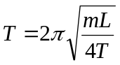
- A body is suspended vertically at the end of a spring that is attached to the ceiling of an elevator. The elevator moves with constant acceleration.
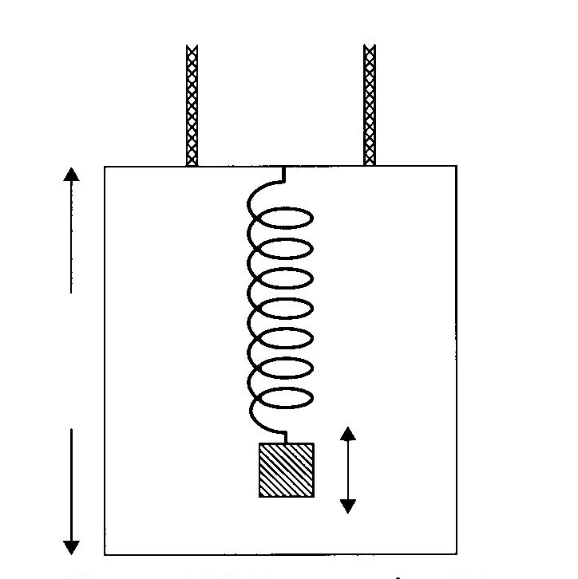
Discuss qualitatively the effect if any of the acceleration on the period of oscillations of the mass when the acceleration is (a) upwards and (b) downwards

- A body of mass 2.0 kg is connected to two springs, each of constant k = 120 Nm⁻¹.
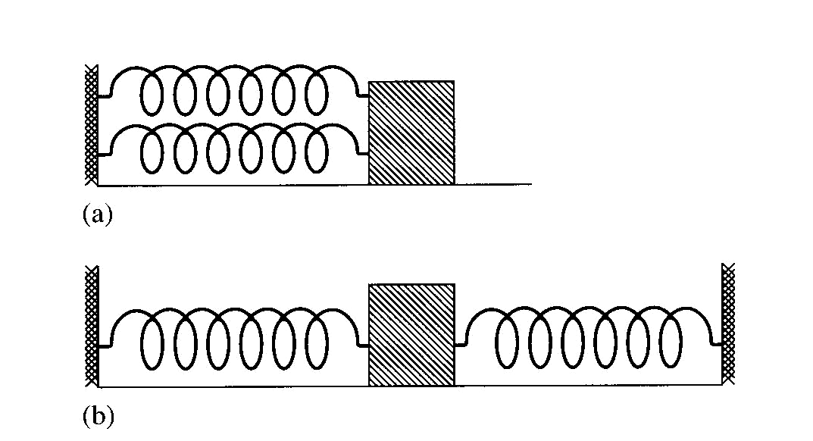
(a) when the springs are connected as in figure (a) calculate the period of oscillations when it is displaced from its equilibrium position and then released.
(b) When the springs are connected instead as in figure (b) would the period change.
ANSWER: (a) 0.57 s
- The graph in the figure shows the variation with time t of the displacement x of a particle undergoing SHM that is under-damped.
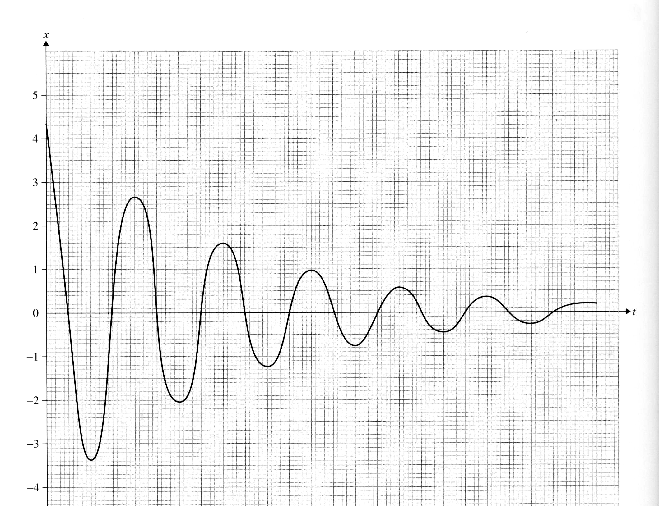

(a) by making measurements on the diagram, determine whether the ratio of successive amplitudes stays constant.
(b) The amount of energy stored in the oscillation is proportional to the square of amplitude. Determine for these oscillations the amount of energy lost in one oscillation as a percentage of the energy stored in the previous oscillation.
(c) One the same axes, draw a graph to show the changes if any to the variation of displacement if the amount of damping were to increase.

ANSWER: (a) 0.61 (b) 37%
- The graph in the figure shows the variation with time t of the displacement x of a [article performing critically damped SHM. On the same axes draw graph to show the variation of displacement when the same system is (a) under – damped (b) over – damped.

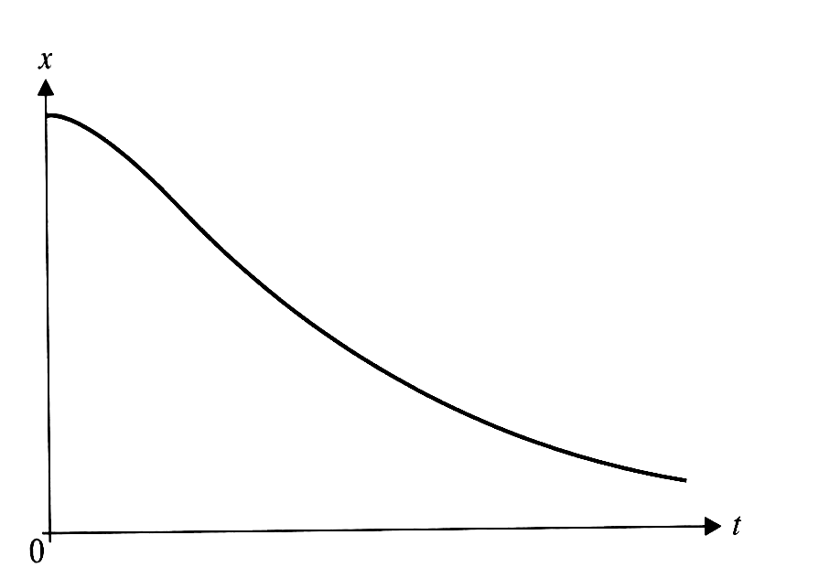
ANSWER:
- A particle of mass m is attached to a horizontal spring of constant k ans executes SHM of amplitude A.
(a) State the angular frequency of oscillation of the particle
(b) deduce that the velocity and displacement of the particle satisfy the realtion
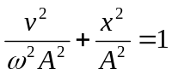
(c) Sketch a graph to show the variation with displacement x of the velocity v of the particle.
(d) Find the area of the graph drawn.
(e) The mass is now subjected to light damping. Suggest how the graph in the figure changes.
ANSWER: (a) 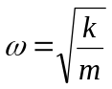(d) πωA²

